**Lesson 12: Confess**

One of the scariest steps in recovery happens in Celebrate Recovery lesson 12 as you begin the process of confession in your life. Without confession, you might end up repeating your mistakes (the ones you thought you were past) over and over again.

Don’t allow yourself to get stuck in a rut! Rather, embrace the positive changes that need to happen through the help of this step!

Celebrate Recovery lesson 12 is very important because it helps you admit where you have gone wrong and find out how to move forward positively!

This lesson goes with Step 5 in Alcoholics Anonymous and [Celebrate Recovery](https://sharinglifeandlove.com/blog/what-is-celebrate-recovery/). Also, it goes with Celebrate Recovery’s principle 4 of [the Celebrate Recovery 8 Principles](https://sharinglifeandlove.com/blog/celebrate-recovery-8-principles-of-recovery-what-they-mean/).

If you are just now joining Celebrate Recovery, you should start with [Celebrate Recovery Lesson 1: Denial](https://sharinglifeandlove.com/blog/celebrate-recovery-lesson-1-denial/). If you’ve been following along with each lesson, refer to [Celebrate Recovery Lesson 11: Spiritual Inventory Part 2](https://sharinglifeandlove.com/blog/celebrate-recovery-lesson-11/) to catch up.

***But if we confess our sins,***

***He will forgive our sins,***

***Because we can trust God to do what is right.***

***He will cleanse us from all the wrongs we have done.***

***1 John 1:9 (NCV)***

Top of Form

Bottom of Form

Table of Contents

[](https://sharinglifeandlove.com/blog/celebrate-recovery-lesson-12/)

* [What is Celebrate Recovery Lesson 12: Confess?](https://sharinglifeandlove.com/blog/celebrate-recovery-lesson-12/#What_is_Celebrate_Recovery_Lesson_12_Confess)
* [What Does “Celebrate Recovery Lesson 12” Mean?](https://sharinglifeandlove.com/blog/celebrate-recovery-lesson-12/#What_Does_%E2%80%9CCelebrate_Recovery_Lesson_12%E2%80%9D_Mean)
* [What Does It Mean to Confess?](https://sharinglifeandlove.com/blog/celebrate-recovery-lesson-12/#What_Does_It_Mean_to_Confess)
* [Celebrate Recovery Lesson 12 Highlights](https://sharinglifeandlove.com/blog/celebrate-recovery-lesson-12/#Celebrate_Recovery_Lesson_12_Highlights)
  + [Celebrate Recovery Lesson 12 Notes](https://sharinglifeandlove.com/blog/celebrate-recovery-lesson-12/#Celebrate_Recovery_Lesson_12_Notes)
  + [#1. Confess any shortcomings, resentments, and sins you have.](https://sharinglifeandlove.com/blog/celebrate-recovery-lesson-12/#1_Confess_any_shortcomings_resentments_and_sins_you_have)
  + [#2. Obey the directions of God.](https://sharinglifeandlove.com/blog/celebrate-recovery-lesson-12/#2_Obey_the_directions_of_God)
  + [#3. Have no more guilt.](https://sharinglifeandlove.com/blog/celebrate-recovery-lesson-12/#3_Have_no_more_guilt)
  + [#4. Begin to face the truth.](https://sharinglifeandlove.com/blog/celebrate-recovery-lesson-12/#4_Begin_to_face_the_truth)
  + [#5. Ease the pain that you are feeling.](https://sharinglifeandlove.com/blog/celebrate-recovery-lesson-12/#5_Ease_the_pain_that_you_are_feeling)
  + [#6. Stop all of the blame.](https://sharinglifeandlove.com/blog/celebrate-recovery-lesson-12/#6_Stop_all_of_the_blame)
  + [#7. Start accepting the forgiveness of God.](https://sharinglifeandlove.com/blog/celebrate-recovery-lesson-12/#7_Start_accepting_the_forgiveness_of_God)
  + [Lesson 12 Questions](https://sharinglifeandlove.com/blog/celebrate-recovery-lesson-12/#Lesson_12_Questions)
* [More Valuable Celebrate Recovery Resources](https://sharinglifeandlove.com/blog/celebrate-recovery-lesson-12/#More_Valuable_Celebrate_Recovery_Resources)
  + [A CR Video – Celebrate Recovery Lesson 12: Confess](https://sharinglifeandlove.com/blog/celebrate-recovery-lesson-12/#A_CR_Video_%E2%80%93_Celebrate_Recovery_Lesson_12_Confess)
  + [Free Recovery Lesson 12 Study Guide](https://sharinglifeandlove.com/blog/celebrate-recovery-lesson-12/#Free_Recovery_Lesson_12_Study_Guide)
* [A Personal Story – Celebrate Recovery Lesson 12](https://sharinglifeandlove.com/blog/celebrate-recovery-lesson-12/#A_Personal_Story_%E2%80%93_Celebrate_Recovery_Lesson_12)
* [Confessing My Sin](https://sharinglifeandlove.com/blog/celebrate-recovery-lesson-12/#Confessing_My_Sin)
* [Letting Go of the Past](https://sharinglifeandlove.com/blog/celebrate-recovery-lesson-12/#Letting_Go_of_the_Past)
  + [A Journey to Look Out For](https://sharinglifeandlove.com/blog/celebrate-recovery-lesson-12/#A_Journey_to_Look_Out_For)
* [A Life Driven by Purpose](https://sharinglifeandlove.com/blog/celebrate-recovery-lesson-12/#A_Life_Driven_by_Purpose)
  + [My Purpose](https://sharinglifeandlove.com/blog/celebrate-recovery-lesson-12/#My_Purpose)
  + [What’s Next?](https://sharinglifeandlove.com/blog/celebrate-recovery-lesson-12/#What%E2%80%99s_Next)
* [Frequently Asked Questions](https://sharinglifeandlove.com/blog/celebrate-recovery-lesson-12/#Frequently_Asked_Questions)
  + [What are the 12 steps of Celebrate Recovery?](https://sharinglifeandlove.com/blog/celebrate-recovery-lesson-12/#What_are_the_12_steps_of_Celebrate_Recovery)
  + [Why Confess?](https://sharinglifeandlove.com/blog/celebrate-recovery-lesson-12/#Why_Confess)
  + [What are the 8 principles of Celebrate Recovery?](https://sharinglifeandlove.com/blog/celebrate-recovery-lesson-12/#What_are_the_8_principles_of_Celebrate_Recovery)
  + [Why Attend Celebrate Recovery at Memorial Road?](https://sharinglifeandlove.com/blog/celebrate-recovery-lesson-12/#Why_Attend_Celebrate_Recovery_at_Memorial_Road)
  + [What is the Serenity Prayer?](https://sharinglifeandlove.com/blog/celebrate-recovery-lesson-12/#What_is_the_Serenity_Prayer)
* [Conclusion](https://sharinglifeandlove.com/blog/celebrate-recovery-lesson-12/#Conclusion)

What is Celebrate Recovery Lesson 12: Confess?

Celebrate Recovery principle 4 is: to Openly examine and confess my faults to myself, to God, and to someone I trust. It’s very freeing! Step 5 says: We admitted to God, to ourselves, and to another human being the exact nature of our wrongs. Get ready for fun!

***Happy are the pure in heart.***

***Matthew 5:8 (TLB)***

***Therefore confess your sins to each other and pray for each other so that you may be healed.***

***James 5:16 (TLB)***

Celebrate Recovery loves acrostics, so in lesson 12, we see the acrostic for **CONFESS**, and it tells us what to do with the inventory we wrote in the previous lessons. We must confess our sins to God, and this is how we are able to do that successfully.

This acrostic comes straight from Celebrate Recovery lesson 12.

* **Confess any of your shortcomings, resentments, and sins!**
* **Obey God’s directions.**
* **There will be No more guilt to face.**
* **Face the truth.**
* **Ease the pain.**
* **Stop the blame.**
* **Start accepting God’s forgiveness**.

***Whoever conceals their sins does not prosper,***

***But the one who confesses and renounces them finds mercy.***

***Proverbs 28:13 (TLB)***



**“You were created to be victorious."**

**Joel Osteen**

What Does “Celebrate Recovery Lesson 12” Mean?

There are step studies in the 12-step recovery program, [Celebrate Recovery](https://sharinglifeandlove.com/blog/what-is-celebrate-recovery/), where you work through the lessons found in the Celebrate Recovery curriculum created by Rick Warren and John Baker.

You typically do this with a small group over a period of many months. To clarify, Celebrate Recovery is a 12-step, *Christ-centered*recovery program [for those with hurts, habits, or hang-ups](https://sharinglifeandlove.com/blog/who-is-celebrate-recovery-for-the-truth-may-shock-you/). If you are honest and serious about recovery, you’d see that everyone qualifies!

The lesson reviewed today is from John Baker’s Celebrate Recovery Participant’s Guide. This is the first lesson from [Getting Right with God, Yourself, and Others: Participant Guide 3](https://amzn.to/3tbRL8R). You can likely purchase this for the same price at a Celebrate Recovery meeting.

The Celebrate Recovery leader guide may vary slightly from the participant’s guide, but all teachings are based on the Beatitudes from the New Testament, so when you hear of [the Celebrate Recovery 8 principles](https://sharinglifeandlove.com/blog/celebrate-recovery-8-principles-of-recovery-what-they-mean/), it will be in reference to those verses of the Bible.

***Teach me to do your will,***

***For you are my God;***

***May your good Spirit lead me on level ground.***

***Psalm 143:10 (TLB)***

What Does It Mean to Confess?

According to [the Merriam-Webster Dictionary](https://www.merriam-webster.com/dictionary/confession), confess means that you are disclosing or revealing your sins to another. As you probably know by now, you have been working hard on your moral inventory in order to confess it to another, and you CAN do this!

Have faith in God and in yourself! Know that you can reveal the deepest darkest secrets of your soul to God, and He loves you in spite of those things!! When you decide to “come clean,” just know you will feel better about everything after you’ve finished!

***If you had faith even as small as a tiny mustard seed,***

***You could say to this mountain,***

***‘Move!’***

***And it would go far away.***

***Nothing would be impossible.***

***Matthew 17:20 (TLB)***

**Celebrate Recovery Lesson 12 Highlights**

**Celebrate Recovery Lesson 12 Notes**

According to the [Celebrate Recovery study guide](https://amzn.to/3tbRL8R), it’s time for you to get right with God and be real with your Celebrate Recovery family. You might think you are the only one to ever commit a sin, but everyone has their own set of baggage!

**#1. Confess any shortcomings, resentments, and sins you have.**

The Lord actually wants you to come clean; you need to admit when you have done wrong things in your life. After all, you are guilty. Just own up to your sins, and you’ll feel at least 90% better!

***Whoever conceals their sins does not prosper,***

***But the one who confesses and renounces them finds mercy.***

***Proverbs 28:13 (TLB)***

**#2. Obey the directions of God.**

When you think about the direction God has for the confession of sin, you must understand the [8 principles of Celebrate Recovery](https://sharinglifeandlove.com/blog/celebrate-recovery-8-principles-of-recovery-what-they-mean/), specifically Principle 4. The Principle states that it is time for us to confess to someone we trust and to God.

Of course, this will mean that you will need to step outside of your comfort zone during those Celebrate Recovery meetings and [make friends](https://sharinglifeandlove.com/blog/how-to-build-a-spiritual-friendship-for-your-life/)! This isn’t easy, but how else will you trust another person enough to share your sins with them?

***“As surely as I am the living God,”***

***Says the Lord,***

***“Everyone will kneel before me,***

***And everyone will confess that I am God.”***

***Every one of us,***

***Then,***

***Will have to give an account to God.***

***Romans 14:11-12 (TLB)***

***Therefore confess your sins to each other and pray for each other so that you may be healed.***

***James 5:16 (TLB)***

**#3. Have no more guilt.**

Do you ever wonder what it means to feel no more guilt? Don’t you think it would be easier to have confidence in our relationships than it would be to continue looking behind us at our old relationships? Celebrate Recovery calls this “review mirror” living.

After you have confessed the things that were making you feel guilt, you will feel a load being hauled off your shoulders. You’ll begin to have a new kind of confidence in your relationships. Positive things will begin to happen in your life.

***All of us have sinned…***

***Yet now God declares us ‘not guilty’…***

***If we trust in Jesus Christ,***

***Who…***

***Freely takes away our sins.***

***Romans 3:23-24 (TLB)***

**#4. Begin to face the truth.**

Since recovery (REAL recovery) requires honesty to work right, you must learn to carry on a normal conversation with God. Listen to the things He says to you through His Word (the Bible). You can do this in [Bible study](https://sharinglifeandlove.com/blog/what-is-a-bible-study/), by memorizing scriptures, and by [simply reading the Bible](https://sharinglifeandlove.com/blog/how-to-start-a-bible-reading-plan/).

Consider purchasing the [Celebrate Recovery Study Bible](https://amzn.to/2XFZs9T) or [Devotional Book (365 Days)](https://amzn.to/3Dxd7kI) for even more recovery insight during your time with God!

You can also learn [how to listen to God](https://sharinglifeandlove.com/blog/how-to-listen-to-god-11-genius-ways/) through a variety of creative methods. Consider looking at your dreams, visions, prayers, writings, drawings, other artwork, and the sounds of nature. All of these things can be a means for you to hear God’s voice.

The next part of the equation can be a bit easier if you have a grasp on [how to pray](https://sharinglifeandlove.com/blog/how-to-pray-for-beginners-a-complete-guide/). Just talk to God and let him know your hurts, habits, hang-ups, and anything else that is bothering you. You are His child, and He wants to hear your voice! You might try [a prayer journal](https://sharinglifeandlove.com/blog/how-to-start-a-prayer-journal/)!

***I am the light of the world.***

***Whoever follows me will never walk in darkness,***

***But will have the light of life.***

***John 8:12 (NIV)***

**#5. Ease the pain that you are feeling.**

According to recovery literature, we are only as sick as the secrets we choose to keep. Once you have shared this with someone else, you will begin to feel less pain, less shame, a healthier self-worth, and a more well-balanced demeanor.

While it can be scary to bare your soul to another, it can also be liberating. Often, we do not experience the rewards in life because we are too afraid of the risks that it takes to get there.

Take the risks! Be bold! You will be glad you did these things in the long run!

***There was a time when I wouldn’t admit what a sinner I was.***

***But my dishonesty made me miserable and filled my days with frustration…***

***My strength evaporated like water on a sunny day until I finally admitted all of my sins to you and stopped trying to hide them.***

***I said to myself,***

***“I confess them to the Lord,”***

***And you forgave me!***

***All my guilt is gone!***

***Psalm 32:3-5 (TLB)***

**#6. Stop all of the blame.**

According to the [Celebrate Recovery study guide](https://amzn.to/3lO0SaV), we can’t expect to find serenity and peace if we keep blaming ourselves and others. Secrets just isolate us from one another! They keep us from being intimate with one another. We, instead, become bashful, scared, and lonely!

***Why do you look at the speck of sawdust in your brother’s eye and fail to notice the plank in your own?***

***How can you say to your brother,***

***‘Let me get the speck out of your eye,’***

***When there is a plank in your own?***

***Take the plank out of your own eye first,***

***Then you can see clearly enough to remove your brother’s speck of dust.***

***Matthew 7:3 (PH)***

Related: [Celebrate Recovery Serenity Prayer](https://sharinglifeandlove.com/blog/celebrate-recovery-serenity-prayer/)

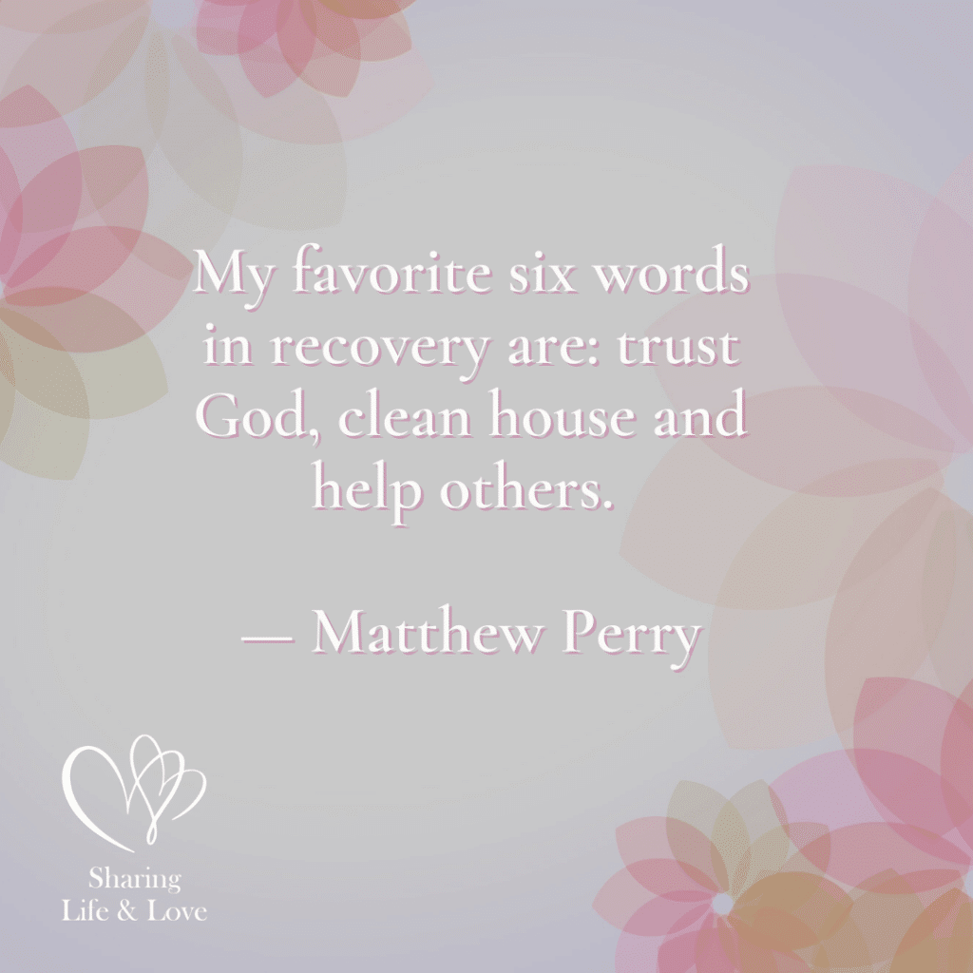

**“My favorite six words in recovery are:**

**Trust God,**

**Clean house and help others.”**

**Matthew Perry**

**#7. Start accepting the forgiveness of God.**

If you completed the last action step, you are ready to finish this one! You are ready to look your Celebrate Recovery family in the eye! You have a better understanding of your “makeup” and now see yourself in a “new light!” Just be humble when you go about this!

***For God was in Christ,***

***Restoring the world to himself,***

***No longer counting men’s sins against them but blotting them out.***

***2 Corinthians 5:19 (TLB)***

***But if we confess our sins,***

***He will forgive our sins,***

***Because we can trust God to do what is right.***

***He will cleanse us from all the wrongs we have already done.***

***1 John 1:9 (NCV)***

**Lesson 12 Questions**

* What resentments, wrongs, or secret sins are keeping you up at night? Would you like to get rid of them?
* What is the value of coming clean of the sins from the past of your life?
* What results do you expect God to produce in your life now that you have obeyed God’s directions for confession?
* What freedoms do you now feel? With the words “no condemnation” and “not guilty” in mind, what are you thinking?
* In the last 4 points (facing the truth, easing the pain, stopping the blame, and starting the acceptance of God’s forgiveness), your life will begin to improve.
  + In what ways can you be more honest?
  + How is your pain eased?
  + How have you stopped blaming?
  + Have you started to see the acceptance of God’s forgiveness?

More Valuable Celebrate Recovery Resources

Free Recovery Lesson 12 Study Guide

In this Recovery Lesson 12 Study Guide, you are presented with more questions to go over with your step study group! It is provided at no cost, so enjoy this free gift!

[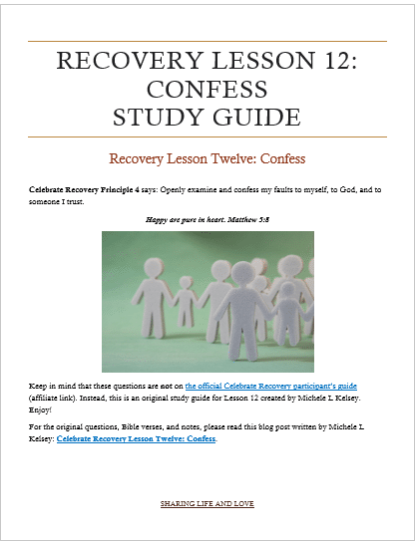](https://sharinglifeandlove.com/product/recovery-lesson-12-study-guide/)

[Recovery Lesson 12 – Confess Study Guide – Sharing Life and Love](https://sharinglifeandlove.com/product/recovery-lesson-12-study-guide/)

**A Personal Story – Celebrate Recovery Lesson 12**

As a graduate of the 12-step program myself, I know the importance of sharing a personal testimony! If you haven’t met me by now, I am Michele, a grateful believer in Jesus Christ.

I celebrate recovery from many addictions and still struggle with anxiety, perfectionism, and other life issues!

Confessing My Sin

While I won’t go into detail about every sin I’ve ever committed, I would like to say that I am not perfect. I’ve committed [sexual sins](https://sharinglifeandlove.com/blog/what-is-christian-sex/) and plenty of wrongdoings that I do not believe were part of God’s plan and I see them now as things I need to confess.

I thought I knew better, so I went with what I wanted to do instead of what I should have done. Don’t we all do that? I mean, we want to tell the truth and say that we have [followed God’s will for our lives](https://sharinglifeandlove.com/blog/how-to-build-a-relationship-with-god-1/), but if we don’t follow His lead, how will we know what that is?

It’s just too easy to follow OUR way over the Lord’s. However, when you [listen to God](https://sharinglifeandlove.com/blog/how-to-listen-to-god-11-genius-ways/) and follow the path that He has laid out for you, you will receive blessings in the long run that you could not even imagine! It’s worth it to take the risk and trust Him!

***We can make our plans,***

***But the Lord determines our steps.***

***Proverbs 16:9 (NLT)***

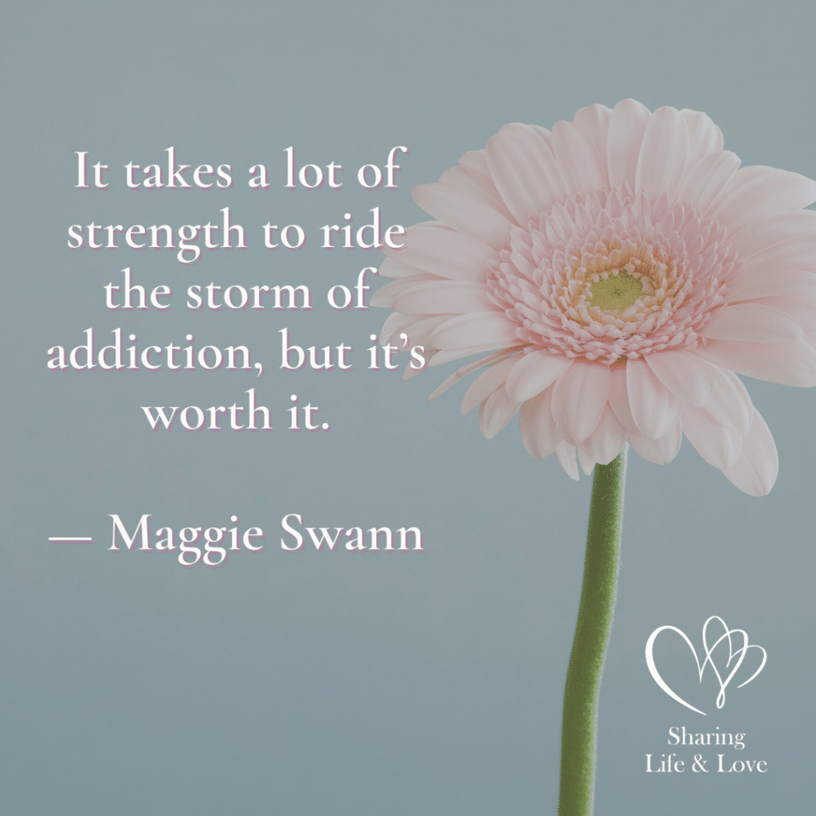

**“It takes a lot of strength to ride a storm of addiction,**

**But it’s worth it.”**

**Maggie Swann**

Letting Go of the Past

Resentment and hard feelings are hard things to let go of. However, we do want to have things turn out for the better, right? The only way we can move forward positively is with God and a better outlook. These two things go hand in hand when it comes to making choices.

I remember as a little girl, I was once punished unfairly (in my opinion) for microwaving silverware utensils that were made of metal. Often, when I was spanked or grounded in any way, it was because of things that I never knew were wrong. Is that fair?

Clearly, I still have a bit of resentment in the oven about the silverware mishap, but I “get” why it still bothers me; I did not know better. As adults, we have a conscience that tells us “right” from “wrong,” so we can make our own decisions and live with the consequences.

That’s where [our relationship with God](https://sharinglifeandlove.com/blog/how-to-build-a-relationship-with-god-3/) comes into play. If we trust Him to lead our lives, He will give us our freewill to make our own mistakes. However, He also gives us the wisdom that we pray for to make the right decisions when we are stuck because of a fork in the road.

***In everything you do,***

***Put God first,***

***And he will direct you and crown your efforts with success.***

***Proverbs 3:6 (TLB)***

A Journey to Look Out For

What does your life look like? Is God the driver of the journey and destination that you think about on a daily basis? Do you feel like you are following His plan for your life? It can be tricky, right?

Continue to [build your relationship with God](https://sharinglifeandlove.com/blog/how-to-build-a-relationship-with-god-2/), and He will make your paths straight. He’ll lead you on the path that goes toward a destiny you can’t even picture in your head. It’s beyond your wildest imaginative thoughts!

***Commit to the Lord whatever you do,***

***And he will establish your plans.***

***Proverbs 16:3 (NIV)***

A Life Driven by Purpose

**My Purpose**

My husband, Bryan, and I recently started reading and following the 40-day plan presented by Rick Warren of Celebrate Recovery in [The Purpose Driven Life](https://amzn.to/3uaQM86). I guess I started reading it a long time ago and still had the journal that accompanies it. This was perfect timing with Lent.

Let me just say that I wish I would have read it when I first owned it, but I know God has His reason for the timing of everything. It truly is a life-changing book! I guess I thought I had already found my path when I began this website, but I see now that He has more for me!

It’s actually quite exciting to learn that your wildest dreams came true and more is to come!

I often think, “Lord, You have surpassed my expectations. What else could You possibly bless me with?” I guess I ask that question more than I think about it. He is THE awesome God!

What’s Next?

It’s not all peaches and gravy, though, that doesn’t sound even a little appealing, does it? How about marshmallows and chocolate shavings?

Does that sound more appetizing? I’m not much of a cook, but I can bake pretty darn well! (We have our fun, right?)

It’s like walking in a Haunted House or something equally exciting; you wonder what the next corner has in store for you, but at the same time, you are thrilled to find out! You’d like to get the reward at the end of the tunnel, and you are willing to accept any molehills along the way!

I might have mixed metaphors there, but you get the picture. Basically, God will bless you beyond your imagination, but ONLY if you allow Him to! While I am blessed to be a writer and creator of a website, I didn’t know that other people would be part of the plan.

God will surprise you if you allow Him to, and if you don’t feel brave, He’ll provide the courage you need at the time when you need it the most. Just trust Him and His specific plan for your individual life! Believe me; He does have a plan made just for YOU!

***Commit everything you do to the Lord.***

***Trust him to help you do it,***

***And he will. Psalm 37:5 (TLB)***

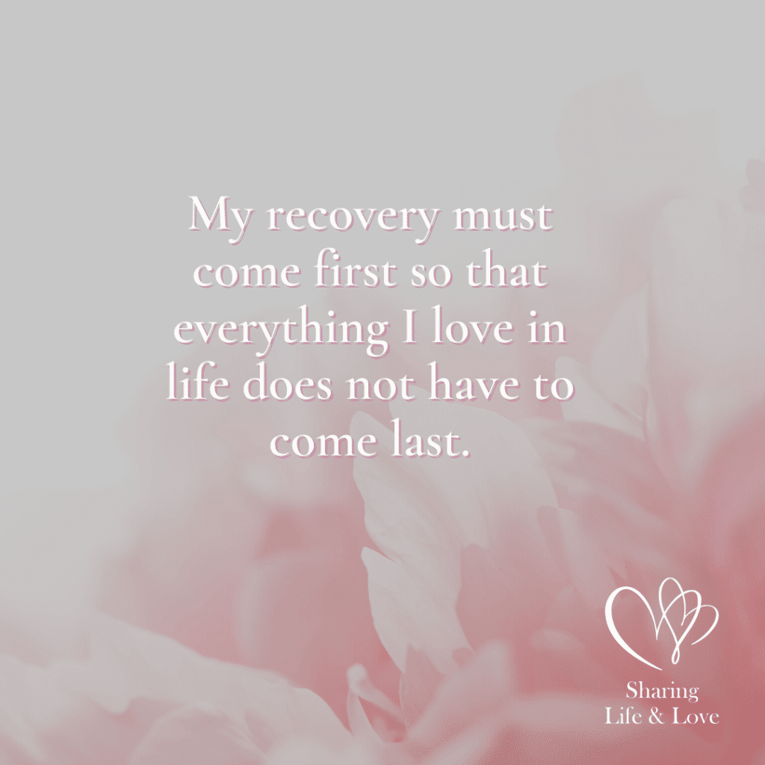

**“Me recovery must come first so that everything I love in life does not have to come last.”**

**Frequently Asked Questions**

What are the 12 steps of Celebrate Recovery?

The 12 steps of Celebrate Recovery are based on the same 12 steps of Alcoholics Anonymous (AA). They include the following:

1. We admitted we were powerless over our addictions and compulsive behaviors, that our lives had become unmanageable.
2. We came to believe that a power greater than ourselves could restore us to sanity.
3. We decided to turn our lives and our wills over to the care of God.
4. We made a searching and fearless moral inventory of ourselves.
5. We admitted to God, ourselves, and another human being the exact nature of our wrongs.
6. We were entirely ready to have God remove all these defects of character.
7. We humbly asked Him to remove all our shortcomings.
8. We made a list of all persons we had harmed and became willing to make amends to them all.
9. We made direct amends to such people wherever possible, except when to do so would injure them or others.
10. We continued to take personal inventory and, when we were wrong, promptly admitted it.
11. We sought through prayer and meditation to improve our conscious contact with God, praying only for knowledge of His will for us and the power to carry that out.
12. Having a spiritual experience resulting from these steps, we try to carry this message to others and practice these principles in all our affairs.

Why Confess?

There are many reasons to confess your sins to God. Of course, the best reason is to “square” yourself with God by being honest and admitting your sin. God already knows this and has forgiven you, but we are still advised to confess our wrong; it helps us grow as people, too!

What are the 8 principles of Celebrate Recovery?

[The 8 principles of Celebrate Recovery](https://sharinglifeandlove.com/blog/celebrate-recovery-8-principles-of-recovery-what-they-mean/) are given to us as follows (and based on the Beatitudes).

1. Realize I’m not God. I admit that I am powerless to control my tendency to do the wrong thing and that my life is unmanageable.
2. Earnestly believe that God exists, that I matter to Him, and that He has the power to help me recover.
3. Consciously choose to commit all my life and will to Christ’s care and control.
4. Openly examine and confess my faults to me, to God, and to someone I trust.
5. Voluntarily submit to every change God wants to make in my life and humbly ask Him to remove my character defects.
6. Evaluate all my relationships. Offer forgiveness to those who have hurt me and make amends for harm I’ve done to others, except when to do so would harm them or others.
7. Reserve a daily time with God for self-examination, Bible reading, and prayer to know God and His will for my life and to gain the power to follow His will.
8. Yield myself to God to be used to bring this Good News to others, both by my example and by my words.

Why Attend Celebrate Recovery at Memorial Road?

Memorial Road Church of Christ in Edmond, Oklahoma is the Celebrate Recovery meeting that I began attending over a decade ago. They have dinner, a large group, small groups, get-togethers, dessert time, step studies, and serving and volunteering opportunities. If you live in the area, get plugged in to this church’s Celebrate Recovery program!

What is the Serenity Prayer?

The [Serenity Prayer](https://sharinglifeandlove.com/blog/celebrate-recovery-serenity-prayer/) from Celebrate Recovery and Alcoholics Anonymous (AA) is as follows: God, grant me the serenity to accept the things I cannot change, the courage to change the things I can, and the wisdom to know the difference. Memorize this prayer for courage in times of trouble!

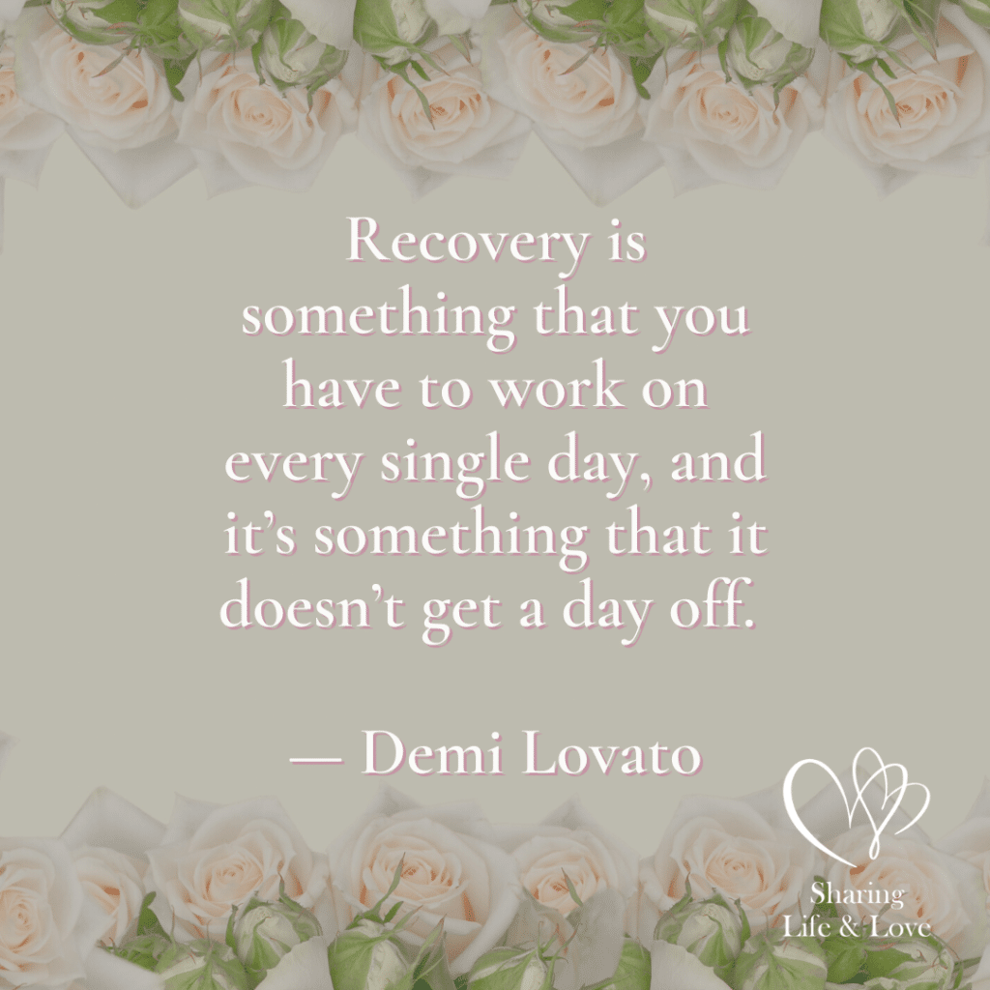

**“Recovery is something that you have to work on every single day,**

**And it’s someht9ing that it doesn’t get a day off.”**

**Demi Lovato**

Conclusion

As you stroll on your way to recovery, I have no doubt that success is staring back at you! In this article on Celebrate Recovery Lesson 12: Confess, we’ve covered:

* What is Celebrate Recovery Lesson 12: Confess?
* An Overview of Celebrate Recovery
* A Summary of the Celebrate Recovery Lesson 12 Study Guide
* The Questions of the Study Guide
* Additional Resources – a FREE Study Guide and CR Video
* My Story as It Relates to Celebrate Recovery Lesson 12
* And a Few More Surprises!