**Lesson 13: Admit**

One of the bravest steps that you can take in recovery is Celebrate Recovery lesson 13 because you continue the process of admitting wrong in your life. Without this step, you might slide back into mistakes that you thought you had conquered.

As you move forward in recovery, embrace all the positive changes that will occur through this step!

Celebrate Recovery lesson 13 is very critical because it helps you admit where you went wrong and determine how to head toward the future!

This lesson accompanies Step 5 in Alcoholics Anonymous (AA) and [Celebrate Recovery](https://sharinglifeandlove.com/blog/what-is-celebrate-recovery/) (CR). It also goes with principle 4 of [the Celebrate Recovery 8 Principles](https://sharinglifeandlove.com/blog/celebrate-recovery-8-principles-of-recovery-what-they-mean/).

If you have just started the Celebrate Recovery lessons, go check out [Celebrate Recovery Lesson 1: Denial](https://sharinglifeandlove.com/blog/celebrate-recovery-lesson-1-denial/). If you are following along with me in order, refer to [Celebrate Recovery Lesson 12: Confess](https://sharinglifeandlove.com/blog/celebrate-recovery-lesson-12/) to catch the last lesson.

***If we confess our sins,***

***He will forgive our sins,***

***Because we can trust God to do what is right.***

***He will cleanse us from all of the wrongs we have done.***

***1 John 1:9 (NCV)***

Table of Contents

[](https://sharinglifeandlove.com/blog/celebrate-recovery-lesson-13/)

* [What is Celebrate Recovery Lesson 13: Admit?](https://sharinglifeandlove.com/blog/celebrate-recovery-lesson-13/#What_is_Celebrate_Recovery_Lesson_13_Admit)
* [What Does “Celebrate Recovery Lesson 13” Mean?](https://sharinglifeandlove.com/blog/celebrate-recovery-lesson-13/#What_Does_%E2%80%9CCelebrate_Recovery_Lesson_13%E2%80%9D_Mean)
* [What Does It Mean to Admit?](https://sharinglifeandlove.com/blog/celebrate-recovery-lesson-13/#What_Does_It_Mean_to_Admit)
* [Celebrate Recovery Lesson 13 Highlights](https://sharinglifeandlove.com/blog/celebrate-recovery-lesson-13/#Celebrate_Recovery_Lesson_13_Highlights)
  + [Celebrate Recovery Lesson 13 Notes](https://sharinglifeandlove.com/blog/celebrate-recovery-lesson-13/#Celebrate_Recovery_Lesson_13_Notes)
  + [#1. Why should I admit my wrongs?](https://sharinglifeandlove.com/blog/celebrate-recovery-lesson-13/#1_Why_should_I_admit_my_wrongs)
  + [#2. Who do I admit my wrongs to?](https://sharinglifeandlove.com/blog/celebrate-recovery-lesson-13/#2_Who_do_I_admit_my_wrongs_to)
  + [#3. Here are some guidelines for your meeting.](https://sharinglifeandlove.com/blog/celebrate-recovery-lesson-13/#3_Here_are_some_guidelines_for_your_meeting)
  + [Lesson 13 Questions](https://sharinglifeandlove.com/blog/celebrate-recovery-lesson-13/#Lesson_13_Questions)
* [More Valuable Celebrate Recovery Resources](https://sharinglifeandlove.com/blog/celebrate-recovery-lesson-13/#More_Valuable_Celebrate_Recovery_Resources)
  + [A CR Video – Celebrate Recovery Lesson 13: Admit](https://sharinglifeandlove.com/blog/celebrate-recovery-lesson-13/#A_CR_Video_%E2%80%93_Celebrate_Recovery_Lesson_13_Admit)
  + [Free Recovery Lesson 13 Study Guide](https://sharinglifeandlove.com/blog/celebrate-recovery-lesson-13/#Free_Recovery_Lesson_13_Study_Guide)
  + [Celebrate Recovery Helpful Products](https://sharinglifeandlove.com/blog/celebrate-recovery-lesson-13/#Celebrate_Recovery_Helpful_Products)
* [My Personal Story – Celebrate Recovery Lesson 13](https://sharinglifeandlove.com/blog/celebrate-recovery-lesson-13/#My_Personal_Story_%E2%80%93_Celebrate_Recovery_Lesson_13)
* [Frequently Asked Questions](https://sharinglifeandlove.com/blog/celebrate-recovery-lesson-13/#Frequently_Asked_Questions)
  + [What are the 12 steps of Celebrate Recovery?](https://sharinglifeandlove.com/blog/celebrate-recovery-lesson-13/#What_are_the_12_steps_of_Celebrate_Recovery)
  + [What are the 8 principles of Celebrate Recovery?](https://sharinglifeandlove.com/blog/celebrate-recovery-lesson-13/#What_are_the_8_principles_of_Celebrate_Recovery)
  + [What is the Celebrate Recovery and AA Serenity Prayer?](https://sharinglifeandlove.com/blog/celebrate-recovery-lesson-13/#What_is_the_Celebrate_Recovery_and_AA_Serenity_Prayer)
  + [What happens at a Celebrate Recovery meeting?](https://sharinglifeandlove.com/blog/celebrate-recovery-lesson-13/#What_happens_at_a_Celebrate_Recovery_meeting)
  + [Is Celebrate Recovery a Biblically-sound program?](https://sharinglifeandlove.com/blog/celebrate-recovery-lesson-13/#Is_Celebrate_Recovery_a_Biblically-sound_program)
* [Conclusion](https://sharinglifeandlove.com/blog/celebrate-recovery-lesson-13/#Conclusion)

What is Celebrate Recovery Lesson 13: Admit?

In Celebrate Recovery principle 4, Openly examine and confess faults to yourself, to God, and to someone you trust. In Step 5, We admitted to God, to ourselves, and to another human being the exact nature of our wrongs. It’s time to get up close and personal! You CAN do this!

***Happy are the pure in heart.***

***Matthew 5:8 (TLB)***

***Therefore confess your sins to each other and pray for each other so that you may be healed.***

***James 5:16 (TLB)***

Celebrate Recovery tells us in lesson 13 the reasons that we need to admit our wrongs to one another. It can be hard to be vulnerable, but you will be able to do it after this lesson!

Top of Form

Bottom of Form



**“Every tear is washing away an old memory that hurts.**

**It’s okay because this is how we let it go.”**

**Tracy Malone**

What Does “Celebrate Recovery Lesson 13” Mean?

The step studies in [Celebrate Recovery](https://sharinglifeandlove.com/blog/what-is-celebrate-recovery/) are the places where you work through the lessons found in the Celebrate Recovery curriculum, which was created by Rick Warren and John Baker. Step studies usually meet for many months in order to cover it all.

Celebrate Recovery is a 12-step, *Christ-centered*recovery program [for people with hurts, habits, or hang-ups](https://sharinglifeandlove.com/blog/who-is-celebrate-recovery-for-the-truth-may-shock-you/). If you are honest and serious about improving your life, realize that CR is for everyone!

The lesson discussed today is from John Baker’s Celebrate Recovery Participant’s Guide. This is the second lesson from [Getting Right with God, Yourself, and Others: Participant Guide 3](https://amzn.to/3tbRL8R). You can most likely purchase this at a Celebrate Recovery meeting.

The Celebrate Recovery leader guide might vary slightly from the participant’s guide, but all teachings are based on the Bible, specifically the New Testament. When you read of [the Celebrate Recovery 8 principles](https://sharinglifeandlove.com/blog/celebrate-recovery-8-principles-of-recovery-what-they-mean/), it will be in reference to the Beatitudes.

***A man who refuses to admit his mistakes can never be successful.***

***But if he confesses and forsakes them,***

***He gets another chance.***

***Proverbs 28:13 (TLB)***

What Does It Mean to Admit?

According to [the Merriam-Webster Dictionary](https://www.merriam-webster.com/dictionary/confession), confessing means to reveal your sins to another. When I looked up the word “admit,” it was actually a synonym of confessing. Last time, we talked about confession to God; now, we will confess or admit our sins to one another.

Have faith in your fellow believers! No one is eager to hear the sins of another or confess their own because this means you must be vulnerable and open to another. Only [true friends](https://sharinglifeandlove.com/blog/make-a-spiritual-friendship/) have this kind of relationship with one another. Having a best friend like this is rewarding!

As you have now made Celebrate Recovery friends in your step study groups and meetings, you now have people who you can turn to in times of trouble. Trust these people with your secrets. Turn to your sponsor when you feel any temptation is too much to bear alone!

These people have been where you are now and can help you along your journey! Believe that the Lord put the people you have in your life there for a reason.

This means that you trust them as you trust Him! He has placed these people in your life for a specific purpose. Get excited!

***Greater love has no one than this:***

***To lay down one’s life for one’s friends.***

***John 15:13 (NIV)***

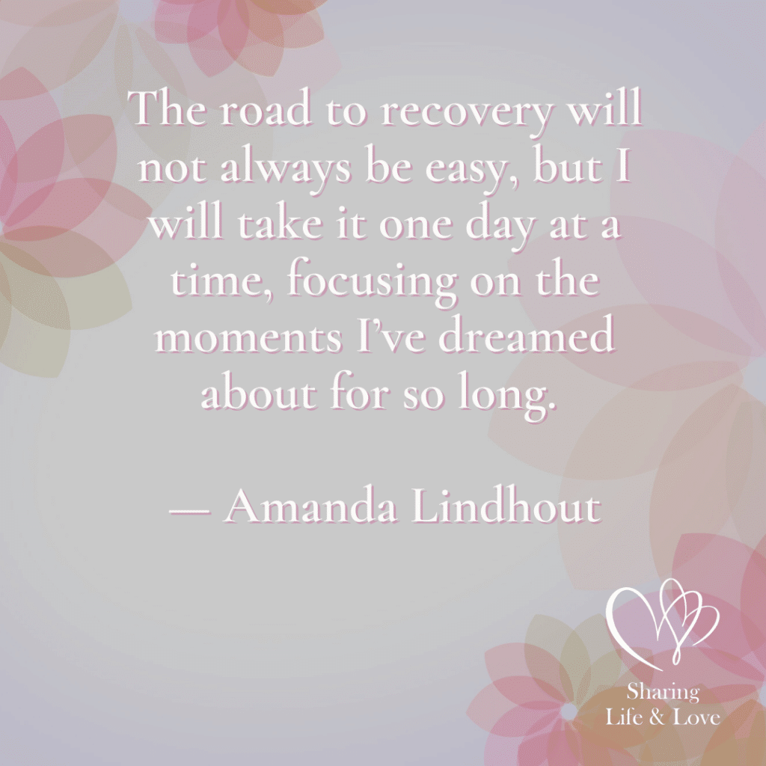

**“The road to recovery will not always be easy,**

**But I will take it one day at a time,**

**Focusing on the moments I’ve dreamed about for so long.”**

**Amanda Lindhout**

**Celebrate Recovery Lesson 13 Highlights**

**Celebrate Recovery Lesson 13 Notes**

According to the [Celebrate Recovery study guide](https://amzn.to/3tbRL8R), it’s time for you to admit your wrongs to your Celebrate Recovery family. Remember that everyone carries baggage in this life, and these people will be there to support you along this journey!

#1. Why should I admit my wrongs?

You’re given three reasons for admitting your wrongs to your Celebrate Recovery family. First, admitting your wrongs will heal you. The Bible says if we confess our sins to one another (admit the wrongs of your life), you’ll receive forgiveness AND healing!

While it’s often easier to walk the road to recovery on your own, it does not work that way in recovery. You need to share your struggles, failures, and secrets with another person – someone in your recovery group. The literature even says we are not to walk alone!

Secondly, admit your wrongs to gain freedom. Secrets and failures (the ugliness in life) keeps us in chains. We stay frozen in time when we don’t admit our wrongs. We can no longer move forward in relationships the way we hoped to!

Admitting our wrongs will snap those chains right off! That means you’ll no longer be bound by what you believe you’ve done wrong in the past – those unspeakable sins that you believe no one can relate to. Everyone has some kind of baggage, so reach out and share!

Finally, by admitting your wrongs, you will gain support. When you decide to share your moral inventory with another individual, you will receive comfort. They can provide you with needed feedback and keep you focused on your recovery!

This individual will [listen closely](https://sharinglifeandlove.com/blog/how-to-listen-better-why-listening-is-so-important-10-reasons/) to what you have to say as you share your life’s inventory and you can count on them to help you get back on track when you face denial or temptation at any time along the way.

***They cried to the Lord in their troubles,***

***And He rescued them!***

***He led them from the darkness and the shadow of death and snapped their chains!***

***Psalm 107:13-14 (TLB)***

#2. Who do I admit my wrongs to?

At your Celebrate Recovery meetings, you are hopefully starting to [make friends](https://sharinglifeandlove.com/blog/how-to-build-a-spiritual-friendship-for-your-life/)! Of course, this isn’t the easiest thing to do, but you need to find people you can trust and rely on to share your inventory with. [Pray about different individuals](https://sharinglifeandlove.com/blog/how-to-pray-for-beginners-a-complete-guide/) you meet to see if they are right for you.

There are a few guidelines for picking the right person to share your inventory with. Keep in mind that an inventory or testimony are very personal things that shouldn’t be shared with those who have led you down the wrong pathways in life.

Rather, they are meant for those who are trustworthy! For Celebrate Recovery, you’ll want to share your inventory with someone who is of the same sex as you. Also, you should respect and know this person; you will be trusting them with your confidence!

Depend on your sponsor or accountability team to help you find the right person or share it with someone that is in that group of people. The main thing you will want to do is to ensure they have completed Principle 4 (or Steps 4 and 5) of [the Celebrate Recovery 8 Principles](https://sharinglifeandlove.com/blog/celebrate-recovery-8-principles-of-recovery-what-they-mean/).

Finally, make an appointment or special date with this person – a time when the two of you will not be distrurbed. It could take about two or three hours to share your inventory, so ensure the two of you have that kind of time available. This is meaningful and time well spent!

***Therefore confess your sins to each other and pray for each other so that you may be healed.***

***James 5:16 (TLB)***

#3. Here are some guidelines for your meeting.

As you set a meeting time with your accountability partner or sponsor, decide to begin your meeting with prayer. Here are a few things you could say in a prayer to God:

* Please fill me with pieces and courage. Give me humility, honesty, and strength.
* As I share my inventory, help me to remember that You have already forgiven me.
* Thank You for sending Jesus to pay the price so that my sins can be forgiven.
* Thank You also for giving me this program and individual to speak with.
* Please continue to strengthen me throughout this process.

***All of us have sinned…***

***Yet now God declares us ‘not guilty’…***

***If we trust in Jesus Christ, who…***

***Freely takes away our sins.***

***Romans 3:23-24 (TLB)***

Some other suggestions include reading the Principle 4 verses during this time, ending the meeting in another prayer, and thanking the person who listened to your inventory.

Also, keep your moral inventory balanced – report the good with the bad! You will be stronger once this is over!

***But if we confess our sins,***

***He will forgive our sins,***

***Because we can trust God to do what is right.***

***He will cleanse us from all the wrongs we have done.***

***1 John 1:9 (NCV)***



**“The fact that you woke up this morning is proof that this day has already been predetermined in your favor.”**

**Russ Kyle**

**Lesson 13 Questions**

* Who are we to confess our inventory to and why? (Hint: You’ll do it three times!)
* Why is it more difficult to confess our wrongs to another person than it is to ourselves and God?
* What is the most difficult part of giving your inventory? What is your biggest fear about doing this? Why?
* What are you most scared of sharing with another person? Why?
* Make a list of three individuals you are considering sharing your inventory with. List the pros and cons of each person. Circle your final choice or decision.
* List three possible quiet locations to share your inventory. Circle the best location for you.

More Valuable Celebrate Recovery Resources

Free Recovery Lesson 13 Study Guide

In the Recovery Lesson 13 Study Guide, you are given even more questions to go over with your small group! It is provided at no cost, so enjoy this free study guide!

Add the link to Study Guide

Celebrate Recovery Helpful Products

To further improve your time with God, you might check out the [Celebrate Recovery Study Bible](https://amzn.to/2XFZs9T) or [Devotional Book (365 Days)](https://amzn.to/3Dxd7kI) for some great recovery tools! Of course, there is much more out there, but that should get you started!!

**My Personal Story – Celebrate Recovery Lesson 13**

As a person who has given her testimony and shared her inventory with another person, I remember how hard it is! By the way, I am Michele – a grateful believer in our Lord Jesus Christ.

I celebrate recovery from addictions and continue to struggle with anxiety, perfectionism, and various life issues!

The lesson was pretty short to talk through, but probably the hardest one to accomplish. You CAN do this, though. Just believe in yourself, and know that the individual you are sharing this with is there to support and love you, not judge!

I remember being nervous, as I did not know what to expect with the person I shared with. Luckily, I was able to share with my supportive sponsor, Angi. If you haven’t found someone to be your sponsor yet, ask around! Talk to the leadership at Celebrate Recovery meetings!

Remember, you will be sharing your inventory with yourself, God, and with someone you trust. If you haven’t written yours yet, be sure to get to work on that! You’ll want it written out so you’ll be able to speak about what you need to. Having it written down will greatly help you!!

Also, keep in mind that no matter who hears your inventory, you need to keep it balanced. If you are just beginning [your relationship with God](https://sharinglifeandlove.com/blog/how-to-build-a-relationship-with-god-1/), you’ll want to talk about the good as well as the bad! Keep it all in perspective when you write it out! You’ve got this in the bag!

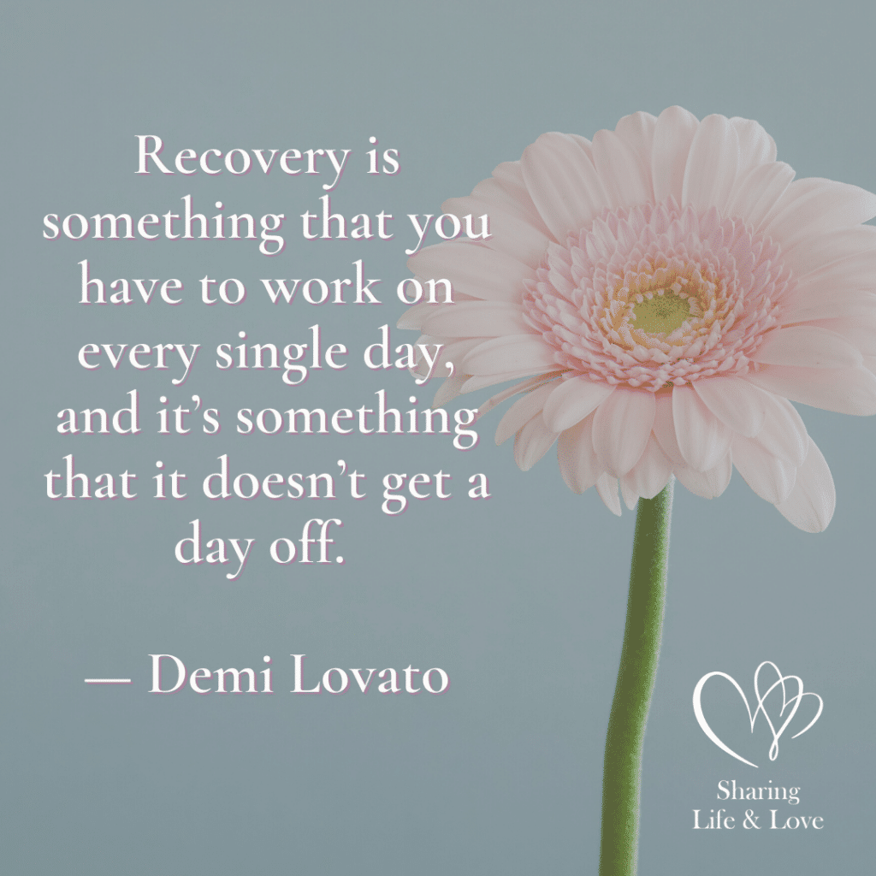

**“Recovery is something that you have to work on every single day,**

**And it’s something that doesn’t get a day off.”**

**Demi Lovato**

**Frequently Asked Questions**

What are the 12 steps of Celebrate Recovery?

The 12 steps of Celebrate Recovery are based on the same 12 steps of Alcoholics Anonymous (AA). They include the following:

1. We admitted we were powerless over our addictions and compulsive behaviors, that our lives had become unmanageable.
2. We came to believe that a power greater than ourselves could restore us to sanity.
3. We decided to turn our lives and our wills over to the care of God.
4. We made a searching and fearless moral inventory of ourselves.
5. We admitted to God, ourselves, and another human being the exact nature of our wrongs.
6. We were entirely ready to have God remove all these defects of character.
7. We humbly asked Him to remove all our shortcomings.
8. We made a list of all persons we had harmed and became willing to make amends to them all.
9. We made direct amends to such people wherever possible, except when to do so would injure them or others.
10. We continued to take personal inventory and, when we were wrong, promptly admitted it.
11. We sought through prayer and meditation to improve our conscious contact with God, praying only for knowledge of His will for us and the power to carry that out.
12. Having a spiritual experience resulting from these steps, we try to carry this message to others and practice these principles in all our affairs.

What are the 8 principles of Celebrate Recovery?

[The 8 principles of Celebrate Recovery](https://sharinglifeandlove.com/blog/celebrate-recovery-8-principles-of-recovery-what-they-mean/) are given to us as follows (and based on the Beatitudes).

1. Realize I’m not God. I admit that I am powerless to control my tendency to do the wrong thing and that my life is unmanageable.
2. Earnestly believe that God exists, that I matter to Him, and that He has the power to help me recover.
3. Consciously choose to commit all my life and will to Christ’s care and control.
4. Openly examine and confess my faults to me, to God, and to someone I trust.
5. Voluntarily submit to every change God wants to make in my life and humbly ask Him to remove my character defects.
6. Evaluate all my relationships. Offer forgiveness to those who have hurt me and make amends for harm I’ve done to others, except when to do so would harm them or others.
7. Reserve a daily time with God for self-examination, Bible reading, and prayer to know God and His will for my life and to gain the power to follow His will.
8. Yield myself to God to be used to bring this Good News to others, both by my example and by my words.

What is the Celebrate Recovery and AA Serenity Prayer?

The [Serenity Prayer](https://sharinglifeandlove.com/blog/celebrate-recovery-serenity-prayer/) of the Celebrate Recovery and Alcoholics Anonymous (AA) program is as follows: God, grant me the serenity to accept the things I cannot change, the courage to change the things I can, and the wisdom to know the difference. Memorize it for more encouragement!

What happens at a Celebrate Recovery meeting?

At a Celebrate Recovery meeting, you can expect some great fellowship. People are real; they want to build friendships that will last a lifetime! They are also there to gain knowledge and understanding when it comes to their struggles, problems, hang-ups, and other life issues. The hope is that we grow from each other and get better!

Is Celebrate Recovery a Biblically-sound program?

Celebrate Recovery is a 12-step recovery program like Alcoholics Anonymous, but it is Biblically-sound. The principles are based on the Beatitudes found in Matthew in the New Testament of the Bible. Also, the lessons and other teachings are based on the Bible and the hope is that your [faith grows](https://sharinglifeandlove.com/blog/how-to-build-a-relationship-with-god-2/) as you recover.



**“Change your mind and life will follow.”**

**Karen Casey**

Conclusion

As you have been on your road to recovery, with the help of this stepping stone, you have now conquered something amazing – you’ve given your inventory!!

In this article on Celebrate Recovery Lesson 13: Admit, we’ve covered:

* What is Celebrate Recovery Lesson 13: Admit?
* An Overview of Celebrate Recovery
* The Basics of the Celebrate Recovery Lesson 13 Study Guide
* The Questions from the Study Guide
* Additional Resources – a FREE Study Guide and a Video
* My Story in Relation to Celebrate Recovery Lesson 13
* And More!