# Celebrate Recovery Lesson 18: Grace

An unforgettable thing happens in recovery during **Celebrate Recovery lesson 18**because you receive a gift – one that you did not know you were due, one you certainly did not earn, and one that will change your life in a positive way. It’s called grace!

How do you accept and model this gift to others? You do it in the manner that **Jesus Christ**did! This is good news and bad news; it’s amazing that we were given a gift like this when we did nothing to deserve it, but we are given a tough example to follow when it comes to grace!

**Celebrate Recovery lesson 18**is an essential part of completing Principle 6. You’ve done many things with this principle, so you can handle this step, I promise!

Lesson 18 goes hand-in-hand with Step 9 of the Alcoholics Anonymous and [Celebrate Recovery](https://sharinglifeandlove.com/blog/what-is-celebrate-recovery/) programs. As mentioned, it also relates to Celebrate Recovery’s principle 6 of [the CR 8 Principles](https://sharinglifeandlove.com/blog/celebrate-recovery-8-principles-of-recovery-what-they-mean/).

If you are new to **Celebrate Recovery**, please check out the first lesson – [Celebrate Recovery Lesson 1: Denial](https://sharinglifeandlove.com/blog/celebrate-recovery-lesson-1-denial/). If you need to catch up with the last lesson, check out [Celebrate Recovery Lesson 17: Forgiveness](https://sharinglifeandlove.com/blog/celebrate-recovery-lesson-17/).

This post may contain affiliate links. Please visit our [Privacy Policy](https://sharinglifeandlove.com/about/privacy-policy/) for more information.

Table of Contents



* [What is Celebrate Recovery Lesson 18: Grace?](https://sharinglifeandlove.com/blog/celebrate-recovery-lesson-18/#What_is_Celebrate_Recovery_Lesson_18_Grace)
* [What Does “Celebrate Recovery Lesson 18” Mean?](https://sharinglifeandlove.com/blog/celebrate-recovery-lesson-18/#What_Does_%E2%80%9CCelebrate_Recovery_Lesson_18%E2%80%9D_Mean)
* [The Gift of Grace in Recovery](https://sharinglifeandlove.com/blog/celebrate-recovery-lesson-18/#The_Gift_of_Grace_in_Recovery)
* [Celebrate Recovery Lesson 18 Highlights](https://sharinglifeandlove.com/blog/celebrate-recovery-lesson-18/#Celebrate_Recovery_Lesson_18_Highlights)
  + [Celebrate Recovery Lesson 18 Notes](https://sharinglifeandlove.com/blog/celebrate-recovery-lesson-18/#Celebrate_Recovery_Lesson_18_Notes)
  + [God’s Gift](https://sharinglifeandlove.com/blog/celebrate-recovery-lesson-18/#God%E2%80%99s_Gift)
  + [Received By Our Faith](https://sharinglifeandlove.com/blog/celebrate-recovery-lesson-18/#Received_By_Our_Faith)
  + [Accepted by God’s Love](https://sharinglifeandlove.com/blog/celebrate-recovery-lesson-18/#Accepted_by_God%E2%80%99s_Love)
  + [Christ Paid the Price](https://sharinglifeandlove.com/blog/celebrate-recovery-lesson-18/#Christ_Paid_the_Price)
  + [Everlasting Gift](https://sharinglifeandlove.com/blog/celebrate-recovery-lesson-18/#Everlasting_Gift)
  + [Completing Principle 6](https://sharinglifeandlove.com/blog/celebrate-recovery-lesson-18/#Completing_Principle_6)
  + [Celebrate Recovery Principle 6b Prayer](https://sharinglifeandlove.com/blog/celebrate-recovery-lesson-18/#Celebrate_Recovery_Principle_6b_Prayer)
  + [Celebrate Recovery Lesson 18 Questions](https://sharinglifeandlove.com/blog/celebrate-recovery-lesson-18/#Celebrate_Recovery_Lesson_18_Questions)
* [More Celebrate Recovery Resources](https://sharinglifeandlove.com/blog/celebrate-recovery-lesson-18/#More_Celebrate_Recovery_Resources)
  + [Free Recovery Lesson 18 Study Guide](https://sharinglifeandlove.com/blog/celebrate-recovery-lesson-18/#Free_Recovery_Lesson_18_Study_Guide)
  + [A CR Lesson 18 Video – Celebrate Recovery Lesson 18: Ready](https://sharinglifeandlove.com/blog/celebrate-recovery-lesson-18/#A_CR_Lesson_18_Video_%E2%80%93_Celebrate_Recovery_Lesson_18_Ready)
  + [Other Celebrate Recovery Resources](https://sharinglifeandlove.com/blog/celebrate-recovery-lesson-18/#Other_Celebrate_Recovery_Resources)
* [A Celebrate Recovery Lesson 18 Personal Story](https://sharinglifeandlove.com/blog/celebrate-recovery-lesson-18/#A_Celebrate_Recovery_Lesson_18_Personal_Story)
  + [Do Not Worry](https://sharinglifeandlove.com/blog/celebrate-recovery-lesson-18/#Do_Not_Worry)
  + [Making Amends](https://sharinglifeandlove.com/blog/celebrate-recovery-lesson-18/#Making_Amends)
* [Frequently Asked Questions](https://sharinglifeandlove.com/blog/celebrate-recovery-lesson-18/#Frequently_Asked_Questions)
  + [What are the 12 steps of Celebrate Recovery?](https://sharinglifeandlove.com/blog/celebrate-recovery-lesson-18/#What_are_the_12_steps_of_Celebrate_Recovery)
  + [What do the numbers mean in Celebrate Recovery?](https://sharinglifeandlove.com/blog/celebrate-recovery-lesson-18/#What_do_the_numbers_mean_in_Celebrate_Recovery)
  + [What are the 8 principles of Celebrate Recovery?](https://sharinglifeandlove.com/blog/celebrate-recovery-lesson-18/#What_are_the_8_principles_of_Celebrate_Recovery)
  + [What is the history of Celebrate Recovery?](https://sharinglifeandlove.com/blog/celebrate-recovery-lesson-18/#What_is_the_history_of_Celebrate_Recovery)
  + [What is the Celebrate Recovery Serenity Prayer?](https://sharinglifeandlove.com/blog/celebrate-recovery-lesson-18/#What_is_the_Celebrate_Recovery_Serenity_Prayer)
* [Conclusion](https://sharinglifeandlove.com/blog/celebrate-recovery-lesson-18/#Conclusion)

## What is Celebrate Recovery Lesson 18: Grace?

**Celebrate Recovery principle 6 is:**Evaluate all my relationships. Offer forgiveness to those who have hurt me and make amends for harm I’ve done to others, except when to do so would harm them or others. Be careful with this step to not cause harm elsewhere!

**Step 9 says:**We made direct amends to such people whenever possible, except when to do so would injure them or others. Be prepared for something amazing with this step!

**Happy are the merciful.**

**Matthew 5:7 (TLB)**

**Happy are the peacemakers.**

**Matthew 5:9 (TLB)**

**Therefore, if you are offering your gift at the altar and there, remember that your brother or sister has something against you, leave your gift there in front of the altar. First, go and be reconciled to them; then come and offer your gift.**

**Matthew 5:23-24 (NIV)**

Celebrate Recovery loves using acrostics, so in lesson 18, we’ll use the acrostic for **GRACE**, which will give us a better understanding of this amazing gift we have received and what to do.

This acrostic is from **Celebrate Recovery lesson 18**.

* **G**od’s Gift
* **R**eceived by our Faith
* **A**ccepted by God’s Love
* **C**hrist Paid the Price
* **E**verlasting Gift

**My grace is enough for you. When you are weak, My power is made perfect in you.**

**2 Corinthians 12:9 (NCV)**

## What Does “Celebrate Recovery Lesson 18” Mean?

At the Christ-centered recovery program, [**Celebrate Recovery**](https://sharinglifeandlove.com/blog/what-is-celebrate-recovery/), you work through the lessons from the curriculum created by Rick Warren and John Baker.

Usually, in a step study group, you’ll work through the lessons over the course of several months. **Celebrate Recovery**was created [for those with hurts, habits, or hang-ups](https://sharinglifeandlove.com/blog/who-is-celebrate-recovery-for-the-truth-may-shock-you/). In all honesty, this applies to everyone because we all face strife in our lives!

Celebrate Recovery Lesson 18 comes directly from **John Baker’s Celebrate Recovery Participant’s Guide**. This is the final lesson in the [Getting Right with God, Yourself, and Others: Participant Guide 3](https://amzn.to/3tbRL8R). You can purchase this online or likely at a Celebrate Recovery meeting.

The Celebrate Recovery leader guide may vary slightly, but all teachings are based on the Bible. In fact, they are from the **Beatitudes**in Matthew of the New Testament. The [Celebrate Recovery 8 principles](https://sharinglifeandlove.com/blog/celebrate-recovery-8-principles-of-recovery-what-they-mean/) refer to those verses.

**Keep this Book of the Law always on your lips; meditate on it day and night, so that you may be careful to do everything written in it. Then you will be prosperous and successful.**

**Joshua 1:8 (NIV)**

## The Gift of Grace in Recovery

[Merriam-Webster](https://www.merriam-webster.com/dictionary/grace) defines **grace**as unmerited divine assistance given to people or a virtue coming from God. Truthfully, what grace is and the many types of grace have always been a bit confusing. After all, why did God give us the gift of grace if we did not earn it?

Specifically, the reasons we received such a gift might be a question for another day. However, it was once explained that **grace**was like **something extra**we get in life.

The example given was explaining **what mercy and grace were**. If you had a nice collection of speeding tickets and a police officer excused them all, that is mercy. **Mercy**is excusing something you did deserve (such as speeding tickets).

**Grace**, on the other hand, would happen if the said police officer gave you a paid vacation to Hawaii on top of excusing your speeding tickets. Wouldn’t that be nice? So, grace is getting something you did not earn or deserve, and mercy is excusing something you did deserve.

We certainly did not deserve the grace that God freely gave us, but it is **a beautiful thing**. Consider [praying today](https://sharinglifeandlove.com/blog/how-to-pray-for-beginners-a-complete-guide/) to thank God for the grace He gave you. Let Him know that you appreciate what His Son, our Lord Jesus Christ, did on the cross!

**What we have received is not the Spirit of the world, but the Spirit who is from God so that we may understand what God has freely given us.**

**1 Corinthians 2:12 (NIV)**

## Celebrate Recovery Lesson 18 Highlights

### Celebrate Recovery Lesson 18 Notes

According to the [Celebrate Recovery study guide](https://amzn.to/3tbRL8R), understanding and appreciating the **gift of grace**that we received from God is a critical part of our salvation.

Let’s look through this lesson’s main points to **better understand grace**and all the wonders it gives you!

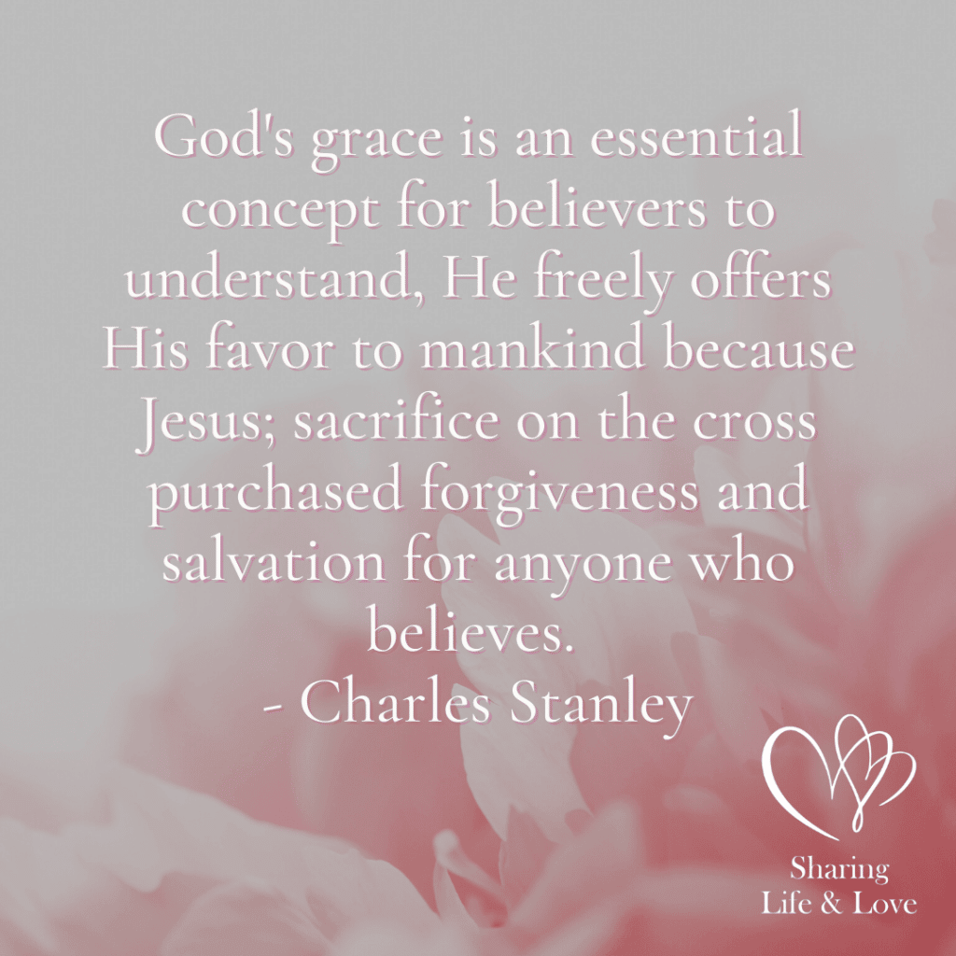

**“God’s grace is an essential concept for believers to understand, He freely offers His favor to mankind because Jesus; sacrifice on the cross purchased forgiveness and salvation for anyone who believes.”**

**Charles Stanley**

### God’s Gift

One thing that is for sure is that you cannot purchase grace. We received God’s grace as a free gift. As we complete **Principle 6**of the [8 Celebrate Recovery Principles](https://sharinglifeandlove.com/blog/celebrate-recovery-8-principles-of-recovery-what-they-mean/), we give amends and offer forgiveness, expecting nothing back or nothing in return for our actions.

**All need to be made right with God by His grace – a free gift. [We] are made free from sin through Christ.**

**Romans 3:24 (NCV)**

Does this sound like something we’ve been discussing – **grace**? It is exactly like what God has given us – something we did not earn, but something that we should be grateful for! God knows this doesn’t come easy for us, and we are given **grace**when trying to give **grace**to others!

Take a moment to [**pray**to God](https://sharinglifeandlove.com/blog/how-to-pray-for-beginners-a-complete-guide/) and **show your appreciation**for the grace He gave you! After you’ve done that, [listen for His voice](https://sharinglifeandlove.com/blog/how-to-listen-to-god-11-genius-ways/). Don’t just expect Him to grant your wishes like a genie, but give Him the glory and respect He deserves! Take the focus off yourself, and change it to Him!

**Prepare your minds for service, having self-control. All your hope should be for the gift of grace that will be yours when Jesus Christ is shown to you.**

**1 Peter 1:13 (NCV)**

### Received By Our Faith

You cannot do work to get to Heaven. It isn’t something you can write off on a checklist and have completed easily. The way to Heaven is through **the profession of your faith in Christ**as your savior. THIS will give you **God’s grace and eternal life**!

**It is by grace that you have been saved, through faith – and this isn’t from yourselves; it’s a gift from God – not by works, so no one can boast.**

**Ephesians 2:8-9 (NIV)**

Through your faith in Christ Jesus, you will find **courage and strength**– exactly what is needed to make your amends and offer forgiveness to others. These aren’t easy tasks, so you need all the courage and strength you can muster. Put your hope in Jesus, and you’ve got it!

**We have gained access by faith into this grace in which we now stand. And we boast in the hope of the glory of God.**

**Romans 5:2 (NIV)**

### Accepted by God’s Love

God loved you when you were sinning, and **grace**is a love that gives; it loves the unlovable and the unlovely. We are able to love other people because the Lord first loved us. We are also able to forgive other people because the Lord forgave us! He is an amazing God!

**We can come before God’s throne where there is grace. There, we can receive mercy and grace to help us when we need it.**

**Hebrews 4:16 (NCV)**

**Forgive us our debts, as we have also forgiven our debtors.**

**Matthew 6:12 (NIV)**

### Christ Paid the Price

Jesus Christ loved us SO much that He was willing to **die on a cross for the forgiveness of our sins**. That includes all of our sins, wrongs, mistakes, pride, selfishness, and much more! Why did He do this? He paid this price so that we could be with Him forever!!

It’s time for us to keep up our end of the deal, though. We do not have to do “works” to enter Heaven because Christ did that, but your entire demeanor, behavior, and actions **change when you become a Christian**! Get rid of that pride and selfishness – for one thing!

Also, **make sacrifices**, **step out of your comfort zone**, and **interact with the world**. Speak to others with truth and love, especially as you finish making amends and offering forgiveness.

**I do not set aside the grace of God, for if righteousness could be gained through the Law, Christ died for nothing.**

**Galatians 2:21 (NIV)**

As you [**get close to Jesus Christ**](https://sharinglifeandlove.com/blog/how-to-build-a-relationship-with-god-1/), there are a few things you can do. Join a [Bible study](https://sharinglifeandlove.com/blog/what-is-a-bible-study/), memorize Bible verses, or start [reading the Bible](https://sharinglifeandlove.com/blog/how-to-start-a-bible-reading-plan/). You might find it useful to start a [prayer journal](https://sharinglifeandlove.com/blog/how-to-start-a-prayer-journal/) to talk to Jesus Christ through prayer!

**In Christ, we are set free by the blood of His death, and so we have the forgiveness of our sins. How rich is God’s grace!**

**Ephesians 1:7 (NCV)**

### Everlasting Gift

Once you have been saved and accepted our Lord Jesus Christ as your one and only Savior, you will receive the gift of grace for the rest of your life. This is a beautiful thing, so take a moment to savor the experience of accepting **God’s grace**in your life.

**I am sure that God, who began the good work within you, will keep right on helping you grow in His grace until His task within you is finally finished on that day when Christ Jesus returns. Philippians 1:6 (TLB)**

**May our Lord Christ Jesus Himself and God our Father encourage you and strengthen you in every good thing you do and say. God loved us, and through His grace, He gave us a good hope and encouragement that continues forever.**

**2 Thessalonians 2:16 (NCV)**

### Completing Principle 6

Now that you have learned about grace, you are ready to **finish Principle 6**. Look at your AMENDS LIST. Highlight any names that you can take care of right away. **Talk to your accountability team**about anyone you are worried you would harm in this process.

Talk to God about your list to make sure you **pick the right time**to make amends or offer forgiveness. This process will take a significant amount of [patience and understanding](https://sharinglifeandlove.com/blog/25-easy-ways-to-improve-your-patience-and-understanding/) with other people, so make sure you are ready for anything!

Finally, **make a plan**to offer amends to those that cannot easily be taken care of. If you are unable to meet with someone on your list for a dire reason, write the individual a letter and share it with your accountability team! You’ve got this!!

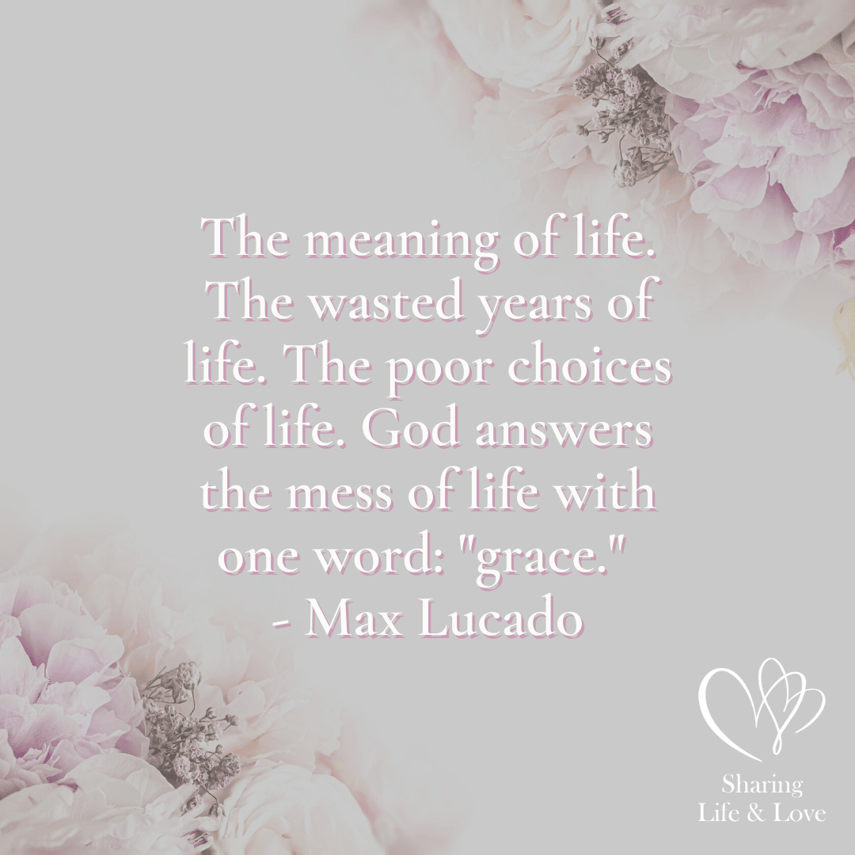

**“The meaning of life. The wasted years of life. God answers the mess of life with one word: “Grace.””**

**Max Lucado**

### Celebrate Recovery Principle 6b Prayer

**Dear Lord,**

**Thank You for loving me and freely giving me grace. Teach me to model Your ways as I make amends and offer forgiveness. Help me set aside any pride and selfishness so that I can speak the truth in love.**

**Please show me how to focus on my part and my responsibility. Thank You for forgiving me for my wrongs so that I can forgive others. Also, thank You for Your love! I love You!**

**In Christ’s Name,**

**Amen**

### Celebrate Recovery Lesson 18 Questions

* How has Christ turned your weaknesses into strengths?
* How can you best receive God’s gift of grace (Romans 5:2)?
* In what ways can you show God’s grace in making your amends?
* How have you experienced God’s grace on your road to recovery?
* How can you model the acceptance that you received from God (Ephesians 2:5) to those you need to make amends and offer forgiveness?
* What does “speaking the truth in love” mean, in your opinion?
* Why should you only focus on YOUR part when making amends or offering forgiveness?
* List things that God has shown you in working Principle 6.

## More Celebrate Recovery Resources

### Free Recovery Lesson 18 Study Guide

In the **Recovery Lesson 18 Study Guide**, you receive even more questions to go over with your CR small group! The study guide is 100% free and original, so please enjoy!

[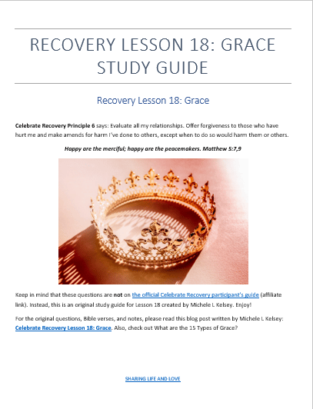](https://sharinglifeandlove.com/product/recovery-lesson-18-study-guide/)

### Other Celebrate Recovery Resources

Additional helpful resources that you might want to use are the [Celebrate Recovery Study Bible](https://amzn.to/2XFZs9T) and the [Celebrate Recovery 365-Day Devotional Book](https://amzn.to/3Dxd7kI)!

## A Celebrate Recovery Lesson 18 Personal Story

Just like at a meeting, I feel it’s important to share a bit about myself, or I wouldn’t be doing what **the Lord has called me**to do, so here goes!

I’m **Michele**, a grateful believer in Jesus.

I **celebrate recovery**from addictions, such as men and alcohol, and struggle with anxiety, control, perfectionism, and patience!

In looking at my story in relation to Celebrate Recovery lesson 18, please note that it’s not easy **bearing your soul**to the world, so I really appreciate my readers accepting me and my faults as part of my being human!! Also, I trust God to use my stories in the way He needs to!

**Commit everything you do to the Lord. Trust Him to help you do it, and He will.**

**Psalm 37:5 (TLB)**

### Do Not Worry

Too often I’ve walked through life worried about the next bad thing that is going to happen. I try to **control**all the dynamics of my life to prevent anything unexpected from happening. This is actually just foolish behavior, but it always made sense to me.

Through recovery, I learned that **worrying too much**was a senseless thing to do, as I can only control my actions and reactions, not the actions and reactions of another person. That’s what was great about giving my amends; I expected nothing back, as I was taught to do in CR!

I actually got married when I graduated High School, thinking I was wise and ready for a big step in life, but mostly because I was with someone who was susceptible to my instruction. In other words, I was a very **controlling wife**and thought I knew the best course of action always.

Of course, this type of **controlling attitude**only will last for so long before the other person takes a stand and decides they will not allow you to control them! It was a tough pill to swallow – understanding that all I thought I was controlling was really **uncontrollable**.

Our marriage, of course, did not last, probably partly due to my **controlling behavior**. If you are a control freak, I would suggest you try to back off from that and allow other people to make their own mistakes, decisions, and actions. It’s **not your job**to control others!

**Therefore do not worry about tomorrow, for tomorrow will worry about itself. Each day has enough trouble of its own.**

**Matthew 6:34 (NIV)**

### Making Amends

When doing this, I recalled how we need to focus on ourselves, not what the other person will do when we offer our amends. **Have an open mind and heart**when you offer amends, and don’t expect some grand gesture on the part of the other person! You can do this!!

**Never pay back evil for evil. Do things in such a way that everyone can see you are honest – clear through. Do not quarrel with anyone. Be at peace with everyone, as much as possible! Romans 12:17-18 (TLB)**

## Frequently Asked Questions

### What are the 12 steps of Celebrate Recovery?

The 12 steps in Celebrate Recovery are the same as those in Alcoholics Anonymous. If you would like to read the twelve steps of Celebrate Recovery or have your own copy to use or frame, please visit [the Shop](https://sharinglifeandlove.com/shop/) at Sharing Life and Love!

### What do the numbers mean in Celebrate Recovery?

The numbers used in Celebrate Recovery can get confusing. There are 25 lessons that correspond with the 8 principles and 12 steps of Celebrate Recovery. Because this is easily misunderstood, there has been a FREE printable made for you in the [Shop](https://sharinglifeandlove.com/shop/) at Sharing Life and Love! 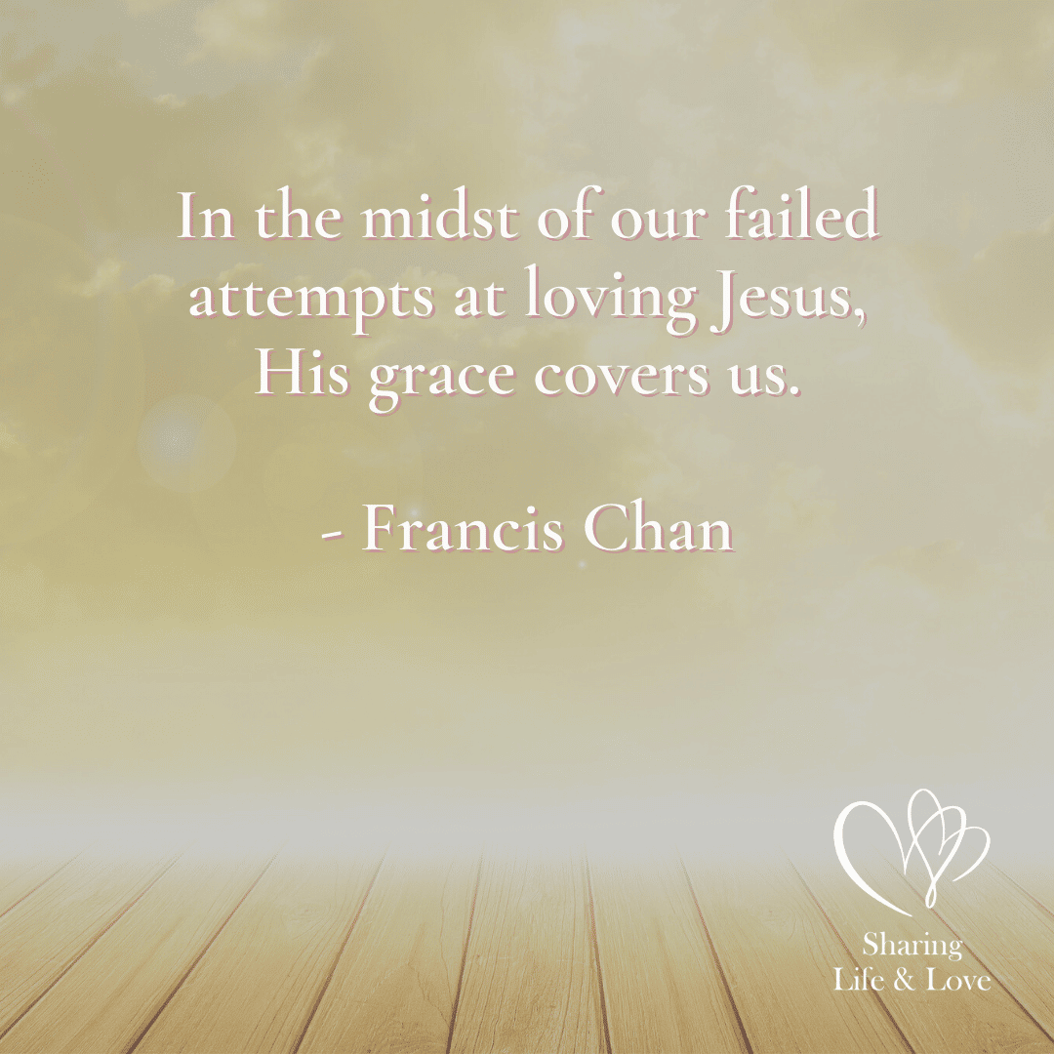

**“In the midst of our failed attempts at loving Jesus, His grace covers us.”**

**Francis Chan**

### What are the 8 principles of Celebrate Recovery?

The [8 principles in Celebrate Recovery](https://sharinglifeandlove.com/blog/celebrate-recovery-8-principles-of-recovery-what-they-mean/) are based on Matthew in the New Testament of the Bible. If you would like to read the 8 principles of Celebrate Recovery or have your own copy to use or frame, please visit [the Shop](https://sharinglifeandlove.com/shop/) at Sharing Life and Love!

### What is the history of Celebrate Recovery?

[Celebrate Recovery](https://www.celebraterecovery.com/about/history-of-cr) began in 1991 at Saddleback Church in California. It was founded by John Baker and Rick Warren. Today, there are over 35,000 churches that participate in Celebrate Recovery, so it is quite large across the nation and even worldwide! Consider joining today!

### What is the Celebrate Recovery Serenity Prayer?

The [Serenity Prayer](https://sharinglifeandlove.com/blog/celebrate-recovery-serenity-prayer/) that is used in Celebrate Recovery (CR) and Alcoholics Anonymous (AA) is as follows: God, grant me the serenity to accept the things I cannot change, the courage to change the things I can, and the wisdom to know the difference. It is recommended that you memorize it for your recovery!

## Conclusion

Congratulations on receiving grace with grace in recovery!! This article on **Celebrate Recovery Lesson 18: Grace**has covered the following:

* What is Celebrate Recovery Lesson 18: Grace?
* An Overview of Celebrate Recovery
* The Celebrate Recovery Lesson 18 Study Guide
* More Study Resources – a FREE Study Guide and Video
* A Personal Story as It Relates to Celebrate Recovery Lesson 18
* Frequently Asked Questions
* And More!