# Lesson 6: Action

# The**most practical step**in recovery occurs in **Celebrate Recovery lesson 6**because you take action to prevent a vicious cycle from continuing in your life. Without this step, you might find yourself **repeating your mistakes**over and over again.

Don’t get stuck in a rut! Instead, **embrace the changes**that need to happen in this step!

If you are **struggling in recovery**, wondering where you will go next, you might just find the answer here because we will cover how you can take action and get unstuck.

Accept Jesus into your heart!

**Celebrate Recovery lesson six**is a **very important**lesson because it encompasses the previous lessons together and places you firmly on your pathway to peace!

This lesson goes with **Step 3** in Alcoholics Anonymous and [Celebrate Recovery](https://sharinglifeandlove.com/blog/what-is-celebrate-recovery/). Also, it corresponds with Celebrate Recovery’s principle 3 of [the Celebrate Recovery 8 Principles](https://sharinglifeandlove.com/blog/celebrate-recovery-8-principles-of-recovery-what-they-mean/).

***If Nothing Changes, Nothing Changes!***

## What is Celebrate Recovery Lesson 6: Action?

**Celebrate Recovery Principle 3 is: to Consciously choose to commit all my life and will to Christ’s care and control.**

**It’s just so liberating!**

**“Blessed are the meek.”**

**Matthew 5:5**

**Step 3 says: We made a decision to turn our lives and our wills over to the care of God.**

**Take that worry off your chest! It’s time to put what we’ve learned into action!**

***“Therefore, I urge you, brothers, in view of God’s mercy, to offer your bodies as living sacrifices, holy and pleasing to God—this is your spiritual act of worship.”***

***(Romans 12:1)***

By now, you know that Celebrate Recovery loves acronyms, so in lesson 6, we use the acronym for **ACTION**, and it tells us how to get unstuck and turn our lives over to Jesus Christ instead.

* **Accept Jesus Christ as your Higher Power and Savior!**
* **Commit to seek and follow His will!**
* **Turn it over.**
* **It’s only the beginning.**
* **One day at a time.**
* **Next: How do I ask Christ into my life?**

**Psalms 25:5 NLT**

**Lead me by your truth and teach me, for you are the God who saves me.**

**All day long I put my hope in you.**

**“Every tear is washing away an old memory that hurts.**

**It’s ok because this is how we let go.”**

**Tracy Malone**

### #1. Accept Jesus Christ as your Higher Power and Savior.

### Make the once in a life-changing decision to welcome Christ Jesus into your heart! Commit your life so that you can establish a personal relationship with Jesus.

Make the **life-changing decision**to welcome Christ Jesus into your heart! Commit your life so that you can establish a personal relationship, something that will change your life forever, with Jesus. He desires this so much, and believe it or not – it will aid you in your recovery!

No one can force you to **change what’s inside your heart and soul**; that’s up to you! The important thing is that you do what’s necessary for your salvation, and the best thing you can do is **establish a relationship with our Lord Jesus Christ**.

As mentioned, this is a life-changing moment because when you accept Jesus Christ as your Savior, you **agree to follow Him**. This doesn’t mean you have to be perfect as a Christian. That is impossible since Jesus was the only perfect man to walk this earth.

So, what does it mean to be a holy and blameless Christian? How can you try to be perfect when you mess up all the time?

It’s simple; just **put your faith in God**. This means **trusting Him**with your life entirely. **Pray**and **study the Bible**to have a stronger relationship with God. There is a [Celebrate Recovery Study Bible](https://amzn.to/2XFZs9T), which you can purchase online.

**If you confess with your mouth,**

**‘Jesus is Lord,’**

**And believe in your heart that God raised Him from the dead,**

**You will be saved.**

**Romans 10:9 (TLB)**

### #2. Commit to seek and follow HIS will!

### We need to change our definition of willpower: Willpower is the willingness to accept God’s power. We see that here is no room for God if we are full of ourselves.

This is when you **trust God**and **accept His power** as you work to recover.

There is no room for God if you are full of yourself.

You need to take a step back and realize that **He is in control**. That means stopping any needless worrying you may be going through and enjoying your life as a Christian.

So, how can you **enjoy life**as a Christian when you see opposition when you look left or right? How can you give up control and allow God to do His work in your life? **Follow Paul’s example**in Philippians. Just open up this small book of the Bible, and you’ll be astounded.

Christ was working in Paul even through multiple trials. Paul was constantly in jail and beaten for being a Christian, but he continued trusting God. He even was **joyful**throughout his suffering because he saw it as a sign that he was doing something right! What an example to follow!

**Teach me to do your will,**

**For you are my God;**

**May your good spirit lead me on level ground.**

**Psalm 143:9-10 (TLB)**

### #3. Turn it over.

### In the third principle we make only the initial decision,

### the commitment to seek and follow God’s will.

### Our walk with our Higher Power, Jesus Christ,

### begins with this decision and is followed by a lifelong process of growing as a Christian.

As you work through your recovery, you may notice that you worry more. What will people think of me now? How will I fit in with my friends?

You may even be worried about relapsing or having setbacks as you try to overcome your hurts and bad habits. **Stop worrying**!

Instead, **turn it all over to God**. Jesus Christ wants a relationship with everyone; no one is too small. Think about the burdens you are carrying on your shoulders, and **allow God to take control**of your life and your worries. He has the **master plan**for you – whether you can see it or not.

Trust in Him, and you will find rest!

**Matthew 11:28-30 NLT**

**Then Jesus said, “Come to me, all of you who are weary and carry heavy burdens,**

**and I will give you rest. Take my yoke upon you.**

**Let me teach you, because I am humble and gentle at heart,**

**and you will find rest for your souls.**

**For my yoke is easy to bear, and the burden I give you is light.”**

### #4. It’s only the beginning.

### In the third principle we make only the initial decision,

### the commitment to seek and follow God’s will.

### Our walk with our Higher Power, Jesus Christ,

### begins with this decision and is followed by a lifelong process of growing as a Christian.

In Celebrate Recovery lesson 3, we made the first decision – to **commit**to seek and follow God’s will for our lives. However, our walk with Jesus Christ does not stop there. It’s **a lifelong process**. Being a Christian takes hard work and willpower, but **you CAN do it**!

Just continue working each and every day to **grow as a Christian**. If you are willing to accept God as your Higher Power, you will find relief in your trials!

Consider [improving your life with prayer](https://sharinglifeandlove.com/blog/how-prayer-can-improve-your-life-the-truth/). If you are unsure of [how to pray](https://sharinglifeandlove.com/blog/how-to-pray-for-beginners-a-complete-guide/), it’s simple; just talk to God as you would a friend. Tell Him what is on your heart and mind. Try using [a prayer journal](https://sharinglifeandlove.com/blog/how-to-start-a-prayer-journal/)! **He wants to hear from you**!

***“And I am certain that God, who began the good work within you, will continue his work until it is finally finished on the day when Christ Jesus returns.”***

***(Philippians 1:6)***

### #5. One day at a time.

### Recovery happens One day at a time. If we remain stuck in the yesterday or constantly worry about tomorrow, we will waste the precious time of the present. We can only change our hurts, hang-ups, and habits in the present. We can only change our hurts, hang-ups, and habits in the present.

True recovery can only happen **one day at a time**. If you are stuck worrying about yesterday or tomorrow, you will not be mindful of what is going on in the present world around you. The only way to change your hurts, habits, or hang-ups is to**stay in the present**.

**Prayer**can help keep you grounded. Consider using a **gratitude journal**, something to help you focus on the here and now. **Mindfulness**, the art of focusing on the present, can be accomplished in several ways, and it’s a great way to [reduce stress and increase your productivity](https://www.redbookmag.com/body/mental-health/g14960504/mindfulness-exercises/).

Consider using [the following tips](https://www.redbookmag.com/body/mental-health/g14960504/mindfulness-exercises/) to **increase mindfulness**:

* Stop multitasking.
* Meditate.
* Let your emotions out.
* Daydream.
* Journal your thoughts and feelings.
* Practice breathing exercises.
* Be yourself.
* Ditch the tech, and enjoy nature!
* Connect your mind and body.
* Practice empathy.
* Travel.
* Take breaks.
* Avoid rash decisions.
* Have fun!

**So, don’t be anxious about tomorrow,**

**God will take care of your tomorrow, too.**

**Live one day at a time.**

**Matthew 6:34 (TLB)**

### #6. Next: How do I ask Christ into my life?

### After you ask Jesus into your heart, you will have a New Life! You will no longer be bound to your old sin nature. God has declared you NOT GUILTY, and you no longer have to live under the power of sin!

According to the [Celebrate Recovery study guide](https://amzn.to/3lO0SaV), the answer is simple. Just answer a few questions. If you answer yes to all of them, you have done your part to **welcome Jesus**into your heart and life. This will help you establish a **spiritual base**for your life.

**Ask yourself if you do the following things.**

Do You: **Believe Jesus Christ died on the cross for you and showed He was God by coming back to life. 1 Corinthians 15:2-4**

*Do You:***Accept God’s free forgiveness for your sins. Romans 3:22**

Do You: **Switch to God’s plan for your life. Romans 12:2; Mark 1:16**

Do You: **Express my desire to Christ to be the director of my life. Romans 10:9**

**If you answered yes and can do those things, pray the following CR prayer:**

**Dear God, I believe that You sent Your Son, Jesus, to die for my sins so I can be forgiven. I’m sorry for the sins in my life. I want to live the rest of my life in the way that You want me to live it. Please put Your Holy Spirit in my life to direct me. Amen.**

## What Does “Celebrate Recovery Lesson 6” Mean?

There are step studies in the recovery program, [Celebrate Recovery](https://sharinglifeandlove.com/blog/what-is-celebrate-recovery/), where you work through the teachings of the Celebrate Recovery curriculum created by Rick Warren and John Baker.

You usually do this with a small group over a period of months. **Celebrate Recovery**is a 12-step, Christ-centered recovery program [for anyone with hurts, habits, or hang-ups](https://sharinglifeandlove.com/blog/who-is-celebrate-recovery-for-the-truth-may-shock-you/).

If we are honest, we all indeed have some of those!

The lesson discussed today is from **John Baker’s Celebrate Recovery Participant’s Guide**. This is the last lesson from [Stepping Out of Denial into God’s Grace: Participant’s Guide 1](https://amzn.to/3CD4Nyc)

**Teach me to do your will,**

**For you are my God;**

**May your good Spirit lead me on level ground.**

**Psalm 143:10 (TLB)**

## What Does It Mean to Take Action?

For the purposes of this CR lesson, **action**refers to getting out of a rut. You may never come out of a cycle of guilt, anger, fear, and depression if you do not take appropriate action. Don’t get stuck in a rut!!

**Taking action**is the only way to get unstuck, get past any roadblocks, and move on to the next step!

**If you had faith even as small as a tiny mustard seed,**

**You could say to this mountain,**

**‘Move!’ and it would go far away.**

**Nothing would be impossible.**

**Matthew 17:20 (TLB)**

**“Change your mind and your life will follow.”**

**Karen Casey**

## How Can You Take Action If You Are Stuck?

Taking action means putting your money where your mouth is. It means finally **showing up for life**and **doing something**about your problems. You may not want to deal with them, may feel like there’s no hope, or may think that you have no options.

There is **always something different**that you can do to change things. Even if you cannot change the circumstances or people around you, you can change your perspective and how you react to or handle certain situations. **YOU**can change!

It will take a little work and you will not change overnight, but you can make things different by the way you act!

## Celebrate Recovery Lesson Six Highlights

### CR Lesson 6 Notes

According to the CR literature, you can easily **get stuck**in a cycle of failure that involves everything from guilt to depression with fear and anger in between! It’s not fun!

The only way to **get unstuck**, to get past any barriers you are facing (guilt, pride, worry, fear, or doubt) – barriers that may be keeping you from moving forward – is to **take action**!

As you go through these points, I want to encourage you to discuss your thoughts and questions with your **small group**, **step study**, or even with **trusted friends and family**.

The point is to find someone who will **listen**to you and allow you to express your feelings and talk through your concerns!

**“The road to recovery will not always be easy,**

**But I will take one day at a time,**

**Focusing on the moments I’ve dreamed about for so long.”**

**Amanda Lindhout**

**Related**: [Celebrate Recovery Serenity Prayer](https://sharinglifeandlove.com/blog/celebrate-recovery-serenity-prayer/)

**“The fact that you woke up this morning is proof that this day had already been predetermined in your favor.”**

**Russ Kyle**

### Lesson 6 Questions

* Now that you have accepted Jesus Christ as your Lord and Savior, what differences have you noticed?
* Has your definition of willpower been altered since you have entered recovery? How?
* What have you turned over to God?
* What do you still need to turn over to Him?
* Now, what is keeping you from turning these things over to Him?
* What does “Live one day at a time” mean to you?
* List the major concerns in your life.
* What is stopping you from turning those concerns over to God?

## More Valuable Celebrate Recovery Resources

### Free Recovery Lesson 6 Study Guide

Here is the **FREE Recovery Lesson Six Study Guide**! It was created by me, not Celebrate Recovery, but it does go along with what was discussed in this lesson. It’s free! Enjoy!

## My Story – Celebrate Recovery Lesson Six

It’s time for me to **be honest**. I have **graduated**from the 12-step program, and I think it’s only fair to give you **my personal testimony**as it relates to this lesson!

First, let me start by **introducing myself**.

I’m **Michele**, and I’m a grateful believer in Christ. I celebrate recovery from addictions and alcoholism. Also, I still am working on my struggles with workaholism, perfectionism, and social anxiety.

### Having Jesus Christ as My Higher Power

Isn’t it interesting how we are often **farthest from God**when everything is “up” – when things are going our way?? Then, when the chips are down, we want to be as **close to God**as possible! Isn’t that odd? I mean, I know things aren’t always that way, but they often are for me.

When I am down and need God, I’m full of the **fruit of the Spirit**. I’m less selfish, more full of kindness, and my whole attitude changes. I know right from wrong, and I make a conscious effort to avoid bad things for myself and be a **shining example to others**!

If you are struggling with knowing how **God fits in your life**, I recommend doing some soul searching. Determine when and where you fell apart from God, what went wrong, and how things are now. You may find it easier to **invite God into your life**now while you are in recovery.

If you haven’t **accepted Christ as your Savior**, what are you waiting for? The timing is never going to be perfect for something like this, but if you **open your heart and mind**, God is always there, waiting to be let in by you; you just have to **open the door**!

**If you confess with your mouth,**

**‘Jesus is Lord,’**

**And believe in your heart that God raised Him from the dead,**

**You will be saved.**

**Romans 10:9 (TLB)**

### Changes in My Willpower

I had trouble turning over my addictions to God, but in terms of my willpower in recovery, in my study guide, I wrote the following about **my changes in willpower**:

I used to think that there were things that made me feel better – things that I could use to feel less empty inside, but now I recognize those things are bad for me. I now try to avoid my addictions to those wrong things and put God in the places where I feel empty inside!

Do you feel empty inside from time to time? What do you fill your life with? If you are a **new or struggling Christian**, like I was, you probably aren’t filling it with God. If you have problems with addictions, what better thing could you be addicted to?

Consider being addicted to God instead of food, drugs, alcohol, sex, or something else!

**In everything you do,**

**Put God first,**

**And he will direct you and crown your efforts with success.**

**Proverbs 3:6 (TLB)**

### Turning It Over to God

When it was time in my recovery to turn things over to God, **I fought it with all my might**. The things that kept holding me back were fear, habit, and self-control. **I was afraid to give up control**, which you may remember from CR Lesson 1! I’m a control freak! Ah!

Also, I formed **bad habits**that were **tough to break**. I **struggled with self-control**and just could not give God control of my future husband and children, which, at the time, were the most important things to me. His timing and plan for my life were just different than what I imagined.

Today, I am blessed to be married to my best friend and to have a family of 5, including pets! **God gave me everything I wanted and more**; I was impatient and wanted everything in my time, not His. He went above and beyond my expectations!

God surpassed my expectations!

We’ve talked a lot about **mindfulness**in this lesson, which I’m not perfect at, but with practice, I learned to live life **one day at a time**, trusting that everything was going to be okay with God. Try saying something like, “Just for today, I will….”

If you look at just the moment in front of you, the task at hand **can seem easy**in comparison to a day’s worth of tasks or a laundry list of to-dos! Think about the next 5 minutes if you need to rather than the next 5 hours. **Break things into smaller chunks,**and they will be more bearable!

**Commit everything you do to the Lord.**

**Trust him to help you do it,**

**And he will.**

**Psalm 37:5 (TLB)**

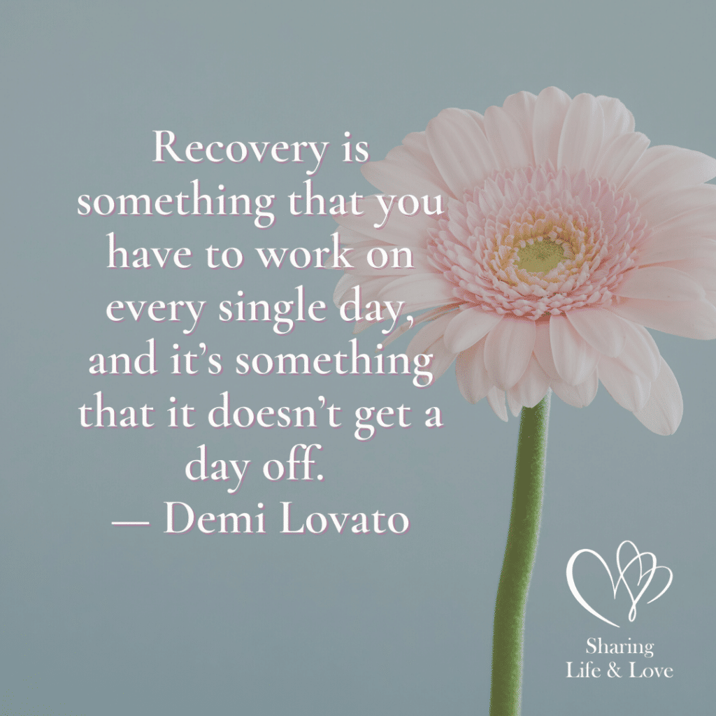

## “Recovery is something that you have to work on every single day,

## And it’s something that it doesn’t get a day off.

## Demi Lovato

## Frequently Asked Questions

### What are the Celebrate Recovery 12 steps?

The **12 steps of Celebrate Recovery**are based on the powerful twelve steps from Alcoholics Anonymous.

1. We admitted we were powerless over our addictions and compulsive behaviors, that our lives had become unmanageable.
2. We came to believe that a power greater than ourselves could restore us to sanity.
3. We decided to turn our lives and our wills over to the care of God.
4. We made a searching and fearless moral inventory of ourselves.
5. We admitted to God, ourselves, and another human being the exact nature of our wrongs.
6. We were entirely ready to have God remove all these defects of character.
7. We humbly asked Him to remove all our shortcomings.
8. We made a list of all persons we had harmed and became willing to make amends to them all.
9. We made direct amends to such people wherever possible, except when to do so would injure them or others.
10. We continued to take personal inventory and, when we were wrong, promptly admitted it.
11. We sought through prayer and meditation to improve our conscious contact with God, praying only for knowledge of His will for us and the power to carry that out.
12. Having a spiritual experience resulting from these steps, we try to carry this message to others and practice these principles in all our affairs.

### What are Celebrate Recovery 8 principles?

The great [8 principles of Celebrate Recovery](https://sharinglifeandlove.com/blog/celebrate-recovery-8-principles-of-recovery-what-they-mean/)are as follows.

1. Realize I’m not God. I admit that I am powerless to control my tendency to do the wrong thing and that my life is unmanageable.
2. Earnestly believe that God exists, that I matter to Him, and that He has the power to help me recover.
3. Consciously choose to commit all my life and will to Christ’s care and control.
4. Openly examine and confess my faults to me, to God, and to someone I trust.
5. Voluntarily submit to every change God wants to make in my life and humbly ask Him to remove my character defects.
6. Evaluate all my relationships. Offer forgiveness to those who have hurt me and make amends for harm I’ve done to others, except when to do so would harm them or others.
7. Reserve a daily time with God for self-examination, Bible reading, and prayer to know God and His will for my life and to gain the power to follow His will.
8. Yield myself to God to be used to bring this Good News to others, both by my example and by my words.

### What is the Celebrate Recovery Serenity Prayer?

The beautiful [Celebrate Recovery (and AA) Serenity Prayer](https://sharinglifeandlove.com/blog/celebrate-recovery-serenity-prayer/) is as follows: God, grant me the serenity to accept the things I cannot change, the courage to change the things I can, and the wisdom to know the difference. This can truly help you in recovery! Memorize it!

### How can I commit to God in my recovery?

The best way to **commit to God**is to have a strong relationship with Him. You can do this by studying your Bible, listening for the words God wants you to hear at this time in your life. Prayer is also critical as you must offer Him thanksgiving for your blessings and submit everything to Him.

### How do I bring God back into my life?

Suppose you have fallen away from the Lord. You can **bring God back into your life**by going to church, fellowshipping with other Christians, attending Celebrate Recovery, reading your Bible, praying, and submitting your life fully to Him in every way. The more you are around Him, the stronger your relationship with Him will get.

## Conclusion

I hope you are on **your way to recovery**with success right now! We’ve covered a lot of material in this article, including:

* What is Celebrate Recovery Lesson 6: Denial?
* An Overview of Celebrate Recovery
* A Summary of the Celebrate Recovery Lesson 6 Study Guide
* Questions from the Study Guide
* Great CR Extras – a Free Study Guide and CR Video
* My Story as It Relates to Celebrate Recovery Lesson 6
* & More!