# Lesson 8: Moral

Probably the**most difficult part**of recovery begins in **Celebrate Recovery lesson 8**because you start taking a moral inventory of your entire life. If you didn’t take this step, you might have trouble moving forward with your recovery as **a moral inventory**is part of the process.

As long as you keep an open mind during this lesson, you will be able to **see significant progress in your journey**, perhaps unlike anything you have ever experienced in your life.

If you have trouble in this step, a **sponsor**or strong **accountability partner**may be the perfect solution – something we went over in detail in the last lesson. They’ll help hold you accountable!

You will find the right motivation to **write your moral inventory**here because we will cover the basics you need to know to accomplish this task!

**Celebrate Recovery lesson 8**is critical as it encompasses all of the previous lessons, placing you firmly on your road to recovery!

This lesson goes with Step 4 in Alcoholics Anonymous and [Celebrate Recovery](https://sharinglifeandlove.com/blog/what-is-celebrate-recovery/). Likewise, it corresponds with Celebrate Recovery’s principle 4 of [the Celebrate Recovery 8 Principles](https://sharinglifeandlove.com/blog/celebrate-recovery-8-principles-of-recovery-what-they-mean/).

No education or expertise is required to be in recovery. You don’t even need to purchase the study guide, but it is recommended. Just keep a pen and paper nearby for this lesson.

If you are **just joining Celebrate Recovery**, check out [Celebrate Recovery Lesson 1: Denial](https://sharinglifeandlove.com/blog/celebrate-recovery-lesson-1-denial/), or if you’ve been going in order, refer to [Celebrate Recovery Lesson 7: Sponsor](https://sharinglifeandlove.com/blog/celebrate-recovery-lesson-7-sponsor/) for the last lesson.

Table of Contents

[](https://sharinglifeandlove.com/blog/celebrate-recovery-lesson-8-moral/)

* [What is Celebrate Recovery Lesson 8: Moral?](https://sharinglifeandlove.com/blog/celebrate-recovery-lesson-8-moral/#What_is_Celebrate_Recovery_Lesson_8_Moral)
* [What Does “Celebrate Recovery Lesson 8” Mean?](https://sharinglifeandlove.com/blog/celebrate-recovery-lesson-8-moral/#What_Does_%E2%80%9CCelebrate_Recovery_Lesson_8%E2%80%9D_Mean)
* [What Does Moral Mean?](https://sharinglifeandlove.com/blog/celebrate-recovery-lesson-8-moral/#What_Does_Moral_Mean)
* [How Can You Be Moral?](https://sharinglifeandlove.com/blog/celebrate-recovery-lesson-8-moral/#How_Can_You_Be_Moral)
* [Celebrate Recovery Lesson 8 Highlights](https://sharinglifeandlove.com/blog/celebrate-recovery-lesson-8-moral/#Celebrate_Recovery_Lesson_8_Highlights)
  + [Celebrate Recovery Lesson 8 Notes](https://sharinglifeandlove.com/blog/celebrate-recovery-lesson-8-moral/#Celebrate_Recovery_Lesson_8_Notes)
  + [#1. Make time.](https://sharinglifeandlove.com/blog/celebrate-recovery-lesson-8-moral/#1_Make_time)
  + [#2. Open your heart.](https://sharinglifeandlove.com/blog/celebrate-recovery-lesson-8-moral/#2_Open_your_heart)
  + [#3. Rely on Jesus.](https://sharinglifeandlove.com/blog/celebrate-recovery-lesson-8-moral/#3_Rely_on_Jesus)
  + [#4. Analyze everything.](https://sharinglifeandlove.com/blog/celebrate-recovery-lesson-8-moral/#4_Analyze_everything)
  + [#5. List it all.](https://sharinglifeandlove.com/blog/celebrate-recovery-lesson-8-moral/#5_List_it_all)
    - [Creating Your Moral Inventory](https://sharinglifeandlove.com/blog/celebrate-recovery-lesson-8-moral/#Creating_Your_Moral_Inventory)
  + [Principle 4 Prayer](https://sharinglifeandlove.com/blog/celebrate-recovery-lesson-8-moral/#Principle_4_Prayer)
  + [Celebrate Recovery Lesson 8 Questions](https://sharinglifeandlove.com/blog/celebrate-recovery-lesson-8-moral/#Celebrate_Recovery_Lesson_8_Questions)
* [More Valuable Celebrate Recovery Resources](https://sharinglifeandlove.com/blog/celebrate-recovery-lesson-8-moral/#More_Valuable_Celebrate_Recovery_Resources)
  + [A CR Video – Celebrate Recovery Lesson 8: Moral](https://sharinglifeandlove.com/blog/celebrate-recovery-lesson-8-moral/#A_CR_Video_%E2%80%93_Celebrate_Recovery_Lesson_8_Moral)
  + [Free Recovery Lesson 8 Moral Inventory Worksheet](https://sharinglifeandlove.com/blog/celebrate-recovery-lesson-8-moral/#Free_Recovery_Lesson_8_Moral_Inventory_Worksheet)
* [My Story – Celebrate Recovery Lesson 8](https://sharinglifeandlove.com/blog/celebrate-recovery-lesson-8-moral/#My_Story_%E2%80%93_Celebrate_Recovery_Lesson_8)
  + [Writing My Moral Inventory](https://sharinglifeandlove.com/blog/celebrate-recovery-lesson-8-moral/#Writing_My_Moral_Inventory)
  + [Stepping Out of Denial](https://sharinglifeandlove.com/blog/celebrate-recovery-lesson-8-moral/#Stepping_Out_of_Denial)
  + [My Relationship with God](https://sharinglifeandlove.com/blog/celebrate-recovery-lesson-8-moral/#My_Relationship_with_God)
* [Frequently Asked Questions](https://sharinglifeandlove.com/blog/celebrate-recovery-lesson-8-moral/#Frequently_Asked_Questions)
  + [What are the Celebrate Recovery 12 steps?](https://sharinglifeandlove.com/blog/celebrate-recovery-lesson-8-moral/#What_are_the_Celebrate_Recovery_12_steps)
  + [What are Celebrate Recovery 8 principles?](https://sharinglifeandlove.com/blog/celebrate-recovery-lesson-8-moral/#What_are_Celebrate_Recovery_8_principles)
  + [What is the Celebrate Recovery Serenity Prayer?](https://sharinglifeandlove.com/blog/celebrate-recovery-lesson-8-moral/#What_is_the_Celebrate_Recovery_Serenity_Prayer)
  + [What is Celebrate Recovery?](https://sharinglifeandlove.com/blog/celebrate-recovery-lesson-8-moral/#What_is_Celebrate_Recovery)
  + [Why Celebrate Recovery?](https://sharinglifeandlove.com/blog/celebrate-recovery-lesson-8-moral/#Why_Celebrate_Recovery)
* [Conclusion](https://sharinglifeandlove.com/blog/celebrate-recovery-lesson-8-moral/#Conclusion)

## What is Celebrate Recovery Lesson 8: Moral?

**Celebrate Recovery principle 4 is: to Openly examine and confess my faults to myself, to God, and to someone I trust. It’s very freeing! Step 4 says: We made a searching and fearless moral inventory of ourselves. Remove all that worry and anxiety, and remember all that you’ve learned in the previous lessons – Trust God!**

**Happy are the pure in heart.**

**Matthew 5:8 (TLB)**

**Let us examine our ways and test them,**

**And let us return to the Lord.**

**Lamentations 3:40 (TLB)**

As Celebrate Recovery loves acronyms, in Celebrate Recovery lesson 8, we see the acronym for **MORAL**, which explains how we are to begin to take a moral inventory of our lives.

This acronym from **Celebrate Recovery lesson 8**is as follows:

* **Make Time**
* **Open**
* **Rely**
* **Analyze**
* **List**

## What Does “Celebrate Recovery Lesson 8” Mean?

As you probably know by now, the step studies in the recovery program, [Celebrate Recovery](https://sharinglifeandlove.com/blog/what-is-celebrate-recovery/), are the places where people go through the Celebrate Recovery curriculum created by Rick Warren and John Baker.

Step studies usually last for an extended period of time, such as a few months. **Celebrate Recovery**is a 12-step, Christ-centered recovery program [for anyone with hurts, habits, or hang-ups](https://sharinglifeandlove.com/blog/who-is-celebrate-recovery-for-the-truth-may-shock-you/). If you are honest with yourself, that applies to you, too!

This lesson (Celebrate Recovery Lesson 8) is from **John Baker’s Celebrate Recovery Participant’s Guide**. This is the second lesson in [Taking an Honest and Spiritual Inventory: Participant’s Guide 2](https://amzn.to/3dEArki). You can most likely buy this study guide in your step study group or at your CR meeting.

The Celebrate Recovery leader guide will vary from the participant’s guide, but all of the teachings are **based on the Beatitudes**(Matthew 5) that are found in the New Testament, so when you study [the Celebrate Recovery 8 principles](https://sharinglifeandlove.com/blog/celebrate-recovery-8-principles-of-recovery-what-they-mean/), you are using those Bible verses.

**God blesses those people who depend only on Him.**

**They belong to the kingdom of heaven.**

**Matthew 5:3 (CEV)**

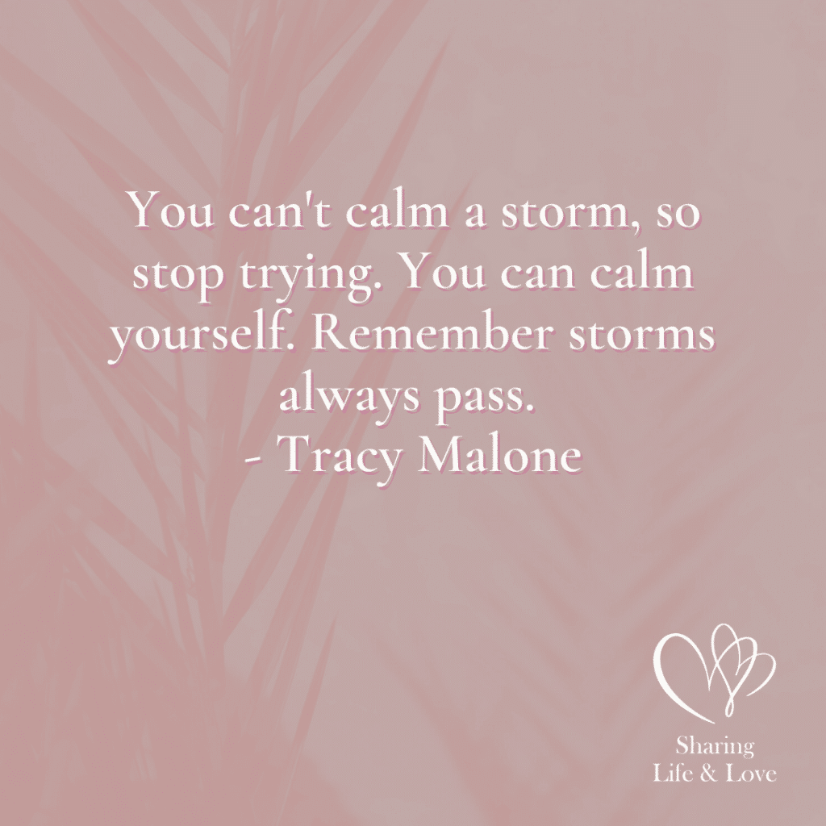

**“You can’t calm a storm,**

**So stop trying.**

**You can calm yourself.**

**Remember storms always pass.”**

**Tracy Malone**

## What Does Moral Mean?

For the purpose of this lesson in Celebrate Recovery, **moral**refers to more than just the difference between right and wrong; it refers to an honest, spiritual decision to do the Christian thing.

Part of taking a moral inventory is being completely forthright with yourself and assessing everything with a truthful approach. If you want to move forward in your recovery, this step must be accomplished with **complete and total honesty**– as hard as it may be!

Ask anyone who has done a recovery inventory, and they will explain **the importance of being honest**with this step. Insignificant errors in your life don’t count here, so don’t worry about each mistake you’ve made in life. You will get through this; you’ve got God on your side!

**With man,**

**This is impossible,**

**But not with God;**

**All things are possible with God.**

**Mark 10:27b (NIV)**

## How Can You Be Moral?

One way that you can be more moral is to live under the Golden Rule – **Do unto others as you would have them do unto you**. Think about how you would like to be treated, and treat others in the same manner.

Another way, which is very similar to the first, is to think about the advice you would give a dear friend with the same problem. Think about how you would advise someone who came to you with an issue that was similar. **Your own insight**might be more profound than you would have believed.

Finally, let’s look at this from a visual standpoint. If you were to have a little devil on one shoulder and a little angel on the other, how would you behave? What kind of decision would you make if **someone were looking over your shoulders**at all times?

**So in everything,**

**Do to others what you would have them do to you**

**Matthew 7:12a (NIV)**

## Celebrate Recovery Lesson 8 Highlights

### Celebrate Recovery Lesson 8 Notes

According to the CR curriculum, you should **begin this step with a sponsor or strong accountability partner**. These things were explained further in the last lesson ([CR Lesson 7: Sponsor](https://sharinglifeandlove.com/blog/celebrate-recovery-lesson-7-sponsor/)), but you should be [making friends](https://sharinglifeandlove.com/blog/how-to-make-christian-friends/) in your Celebrate Recovery meetings.

As you make new friends, work hard to [build those friendships](https://sharinglifeandlove.com/blog/how-to-build-a-spiritual-friendship-for-your-life/) so that you will have plenty of people to turn to for **accountability**. You’ll need people in your life that you can trust and [get encouragement from](https://sharinglifeandlove.com/blog/how-to-encourage-someone/).

As you go through the points in this lesson, try to be open to discussing these things with other people, especially **your new Celebrate Recovery friends**! You won’t want to go through these points alone, so make certain you are open to new people and new experiences in CR.

I know it’s not easy because these things are personal but **work at trusting others,**and you’ll **find greater rewards**because of it.

The **purpose of this lesson**is to list all of the significant events in your life – your moral inventory.

For this inventory, you will list both good and bad things, the things that have affected your life the most. As mentioned, part of listing these events is being very **honest**. This way, God can work in your life and help you **determine how the significant events affected your life**and that of others.



**“Your best days are ahead of you.**

**The movie starts when the guy gets sober and puts his life back together;**

**It doesn’t end there.”**

**Bucky Sinister**

### #1. Make time.

You should be ready to set aside a significant amount of time to **begin the inventory**of your life. It will take some thought and careful consideration. You might want to **set an appointment with yourself**, especially if you have a hectic schedule that stays full.

You might need an entire day or a whole weekend to be able to **do your moral inventory**. This is **time that you will be spending alone with God**. Try not to think too much of your normal hectic lifestyle during this time, so you can be more**fully present**with the Lord.

You might want to gather [a few Bibles and reference books](https://sharinglifeandlove.com/blog/how-to-build-a-bible-library/) to fully embrace this time with God. If you don’t have a study Bible, there is a [Celebrate Recovery Study Bible](https://amzn.to/2XFZs9T) that you can buy online.

There is also a [365-Day Celebrate Recovery Devotional Book](https://amzn.to/31KruDX) that helps with Bible study and healing during recovery!

**Then listen to me.**

**Keep silent,**

**And I will teach you wisdom!**

**Job 33:33 (TLB)**

### #2. Open your heart.

This can be quite difficult, but in order to do **a full inventory of your life**, you must be willing to open your heart and mind. Even if you have painful memories and are striving to block out the associated feelings, try to go against this sensation. You need to bring it all out into the open.

As you “wake up” the past feelings you have been avoiding, you might **ask yourself a few questions**to stir things up.

* What do I feel guilty about?
* What am I trying to avoid?
* Is there anything I am resentful about?
* Who do I feel resentment toward?
* What do I fear?
* Do I have feelings of dishonesty about anything in particular?
* Do I feel self-pity?

As these feelings come to light, you may feel quite uncomfortable. It won’t be fun to feel this way, but it will **help you reach the next step**in your recovery. Consider it the “pain” you must feel to get the “gain” out of this experience. It will be over before you know it!

**Let me express my anguish.**

**Let me be free to speak out of the bitterness of my soul.**

**Job 7:11 (TLB)**

### #3. Rely on Jesus.

During this time of reflection, make it a point to **depend on Jesus Christ**, your Higher Power, the one who will be able to give you the courage and strength you need to complete this exercise.

You might feel unwanted feelings, and other emotions may surface! **The Lord can be your rock**if you allow Him to! He will be able to get you through this like no one else can!

If you begin to feel discouraged or weary, **find your strength**in Him! If you think that you won’t be able to complete this exercise and maintain your sanity, depend on Him! You can do this!!

**Love the Lord,**

**All of you who are His people;**

**For the Lord protects those who are loyal to Him…**

**So cheer up!**

**Take courage if you are depending on the Lord!**

**Psalm 31:23-24 (TLB)**

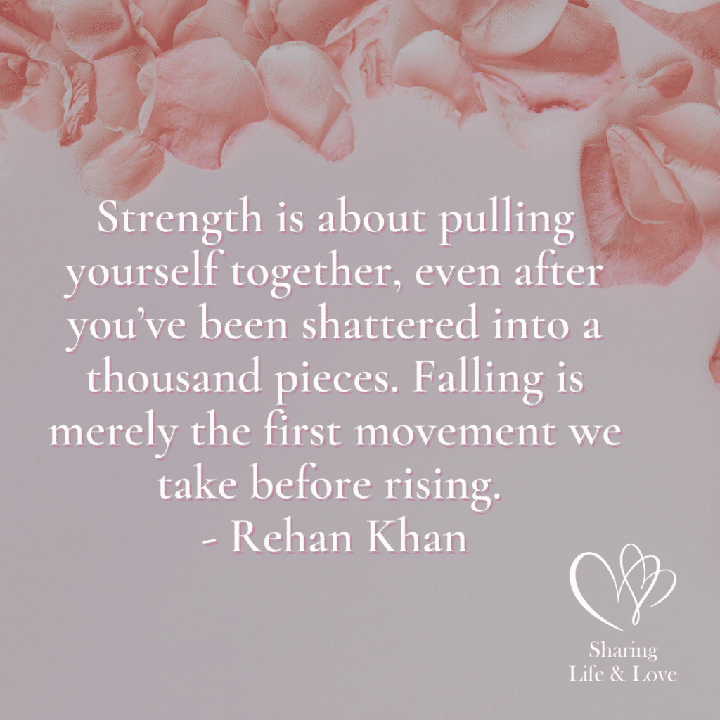

**“Strength is about pulling yourself together,**

**Even after you’ve been shattered into a thousand pieces.**

**Falling is merely the first movement we take before rising.”**

**Rehan Khan**

### #4. Analyze everything.

In [Celebrate Recovery lesson 1](https://sharinglifeandlove.com/blog/celebrate-recovery-lesson-1-denial/), we learned to **step out of denial**, so there is no room for that anymore! It’s time for you to honestly assess your life in the past, having a fearless inventory of what’s happened. This means that you cannot have feelings of denial. You must **be honest**!

To **do this moral inventory the right way**, you must get to the bottom of the things in your past that bother you. Discover the truth of why you are who you are today, even if it is painful to do so! The pain will heal, the tears will stop, and the sorrow will dissipate – with time.

**The Lord gave us mind and conscience;**

**We cannot hide from ourselves.**

**Proverbs 20:27 (TLB)**

### #5. List it all.

It’s important that you list both the good and the bad things that have happened to you. Make sure you **keep your inventory balanced**. That means that you will list the wonderful blessings that have come into your life, as well.

According to the [Celebrate Recovery official study guide](https://amzn.to/3dEArki), if you only look at the bad things that happened to you in the past, you will cause yourself to have unnecessary pain and discomfort. There’s no reason to do that. Think of the things that have **made you smile**in the past.

Here are a **few helpful ideas**to get the ball rolling:

* Births
* Weddings
* Birthdays
* Christmas
* Holidays
* Celebrations
* Reunions

Of course, not all of these things will bring back pleasant memories, but perhaps by scanning the list, you will be able to recall a few wonderful things that happened to you. Sometimes, **the best things**happen to us after a trial or tribulation.

Look at the **Bible verse**that correlates to this point.

**Let us examine our ways and test them.**

**Lamentations 3:40a (NIV)**

Notice that it doesn’t say to examine only the bad things that have happened to you. It doesn’t indicate we should only look at the negative. Be sure to **even things out**– explore both the good and bad. You might cause yourself a great deal of pain if you don’t.

#### Creating Your Moral Inventory

As you **create your moral inventory**, you will discover many harmful things from your past, things that hurt you and/or others. It won’t necessarily be fun, but no one has a perfect life. Everyone has a flawed list. We’ve all missed the mark from time to time.

In recovery, we don’t dwell on the past, but we do make a serious effort to **understand it**so that we can allow God to change us in the way that He deems necessary. He wants our lives to be full and complete but in the right way. Only He can dictate that.

**My purpose is to give life in all its fullness.**

**John 10:10 (TLB)**



**“It’s crazy,**

**How similar we are.**

**Here’s both of us,**

**Working through our stuff,**

**Trying to make something positive out of something really bad.”**

**Jenny Han**

### Principle 4 Prayer

**Dear God, You know my past, all the good and the bad things that I’ve done. In this step, I ask that You give me the strength and the courage to list those things so that I can “come clean” and face them and the truth.**

**Please help me reach out to others You have placed along my “road to recovery.” Thank You for providing them to help me keep balanced as I do my inventory. In Christ’s name, I pray, Amen**.

**Related**: [Celebrate Recovery Serenity Prayer](https://sharinglifeandlove.com/blog/celebrate-recovery-serenity-prayer/)

### Celebrate Recovery Lesson 8 Questions

* Where will you go for quiet time to begin your inventory?
* What date have you set to begin? What time?
* What are your fears as you start your inventory? Why?
* What can you do to help “wake up” your feelings?
* Describe your experience of turning your life over to Jesus Christ.
* How do you try to turn over your will to God’s care on a daily basis?
* List the things you have used to block out the pain of your past.
* What have you done so far to step out of denial?
* How can you keep finding new ways out of your denial of the past?
* Why is it important to do a written moral inventory?
* What are some of the good things that you have done in your life?
* What are some of the negative things that you have done in your life?
* Do you have a sponsor or accountability partner to help you keep your moral inventory balanced?

## More Valuable Celebrate Recovery Resources

### Free Recovery Lesson 8 Moral Inventory Worksheet

Enjoy the **Recovery Lesson Eight Moral Inventory Worksheet**! I created it, not Celebrate Recovery, but it does go with this lesson and is **FREE**! Use this worksheet to help you create your moral inventory! I hope it’s an excellent experience for you!!

[My Moral Inventory Brainstorming Worksheet](https://sharinglifeandlove.com/product/my-moral-inventory-brainstorming-worksheet/)

[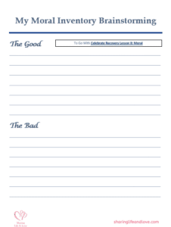](https://sharinglifeandlove.com/product/my-moral-inventory-brainstorming-worksheet/)

## My Story – Celebrate Recovery Lesson 8

As you may know by now, I have completed the Celebrate Recovery 12-step program. My name is **Michele**, and I’m a grateful believer in Christ Jesus. I celebrate recovery from several addictions and alcoholism. Still, I struggle with perfectionism and anxiety.

### Writing My Moral Inventory

When writing **my moral inventory**, I went to a room in my house where there were the fewest distractions. I was a bit hesitant to start my moral inventory because I was overwhelmed by everything that’s happened in my life. I should have trusted God to show me the way more!

Many things had **caused me turmoil**in my life, and I was worried new resentments would develop as I did my moral inventory because of pain that might resurface.

The easiest way for me **to “wake up” old feelings**was to look at old pictures, read my old diaries, and review old journal entries. Often, as I worked on my inventory, I realized I was trying to forget things of the past or rationalize my actions.

Sometimes, we don’t realize we are in denial about something until it shakes us!

### Stepping Out of Denial

To **get in touch with the feelings**that I was in denial about, I kept these things in the forefront of my mind. This way, I could continue remembering what I was having problems with so that I could avoid having the same problems I’ve had in the past.

When I realized I was **still in denial** about many things, my sponsor encouraged me to avoid temptations. I had an addiction to men, and deleting phone numbers from my phone helped me on my road to recovery! I also restricted myself in any way from contacting men I was romantic about.

Once I realized what **my problems**were and where they came from, I was able to “look out” for them and stop myself before I do things in excess since I tend to have an addictive personality.

**Writing my moral inventory**was a good way to determine the good and bad things that contributed to my addictions. By writing them down, I was able to avoid these activities in the future. I found that journaling this out took away the power and pain of it all.

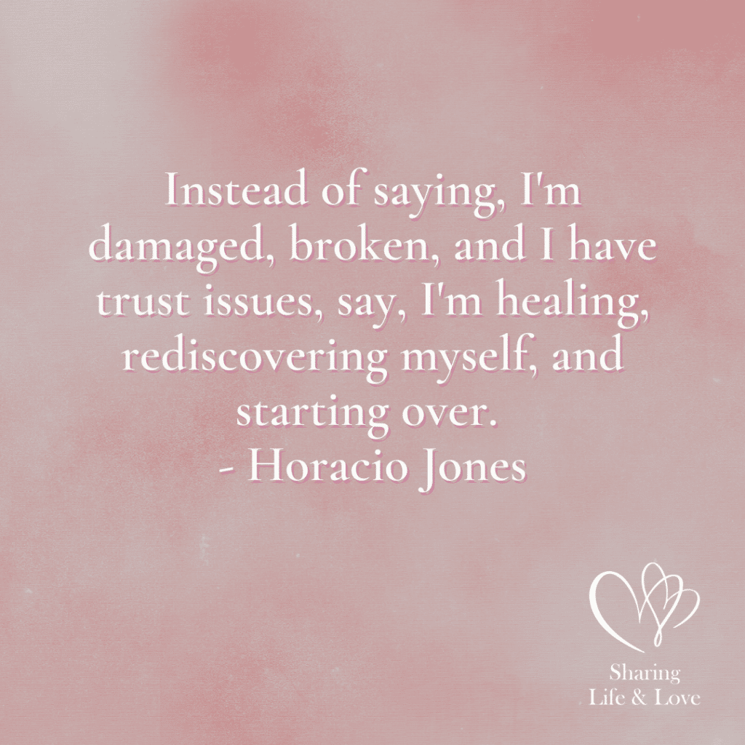

**“Instead of saying,**

**I’m damaged,**

**Broken,**

**And I have trust issues,**

**Say,**

**I’m healing,**

**Rediscovering myself,**

**And starting over.”**

**Horacio Jones**

### My Relationship with God

I gained a **close connection with God**in my youth. To turn myself over daily to God’s care, I try to set an example of a Christian to the best of my ability. My goal is for others to see why I’m different and wonder why.

**Being an example to others**involves avoiding things that cause me trouble – no matter how trivial they may seem. This is why my recovery is so critical. I don’t want others to see me doing the wrong things and think I am full of earthly things, not things of heaven.

**Set your minds on things above,**

**Not on earthly things.**

**Colossians 3:2 (NIV)**

## Frequently Asked Questions

### What are the Celebrate Recovery 12 steps?

The **12 steps of Celebrate Recovery (CR)**are based on the 12 steps from Alcoholics Anonymous (AA).

1. We admitted we were powerless over our addictions and compulsive behaviors, that our lives had become unmanageable.
2. We came to believe that a power greater than ourselves could restore us to sanity.
3. We decided to turn our lives and our wills over to the care of God.
4. We made a searching and fearless moral inventory of ourselves.
5. We admitted to God, ourselves, and another human being the exact nature of our wrongs.
6. We were entirely ready to have God remove all these defects of character.
7. We humbly asked Him to remove all our shortcomings.
8. We made a list of all persons we had harmed and became willing to make amends to them all.
9. We made direct amends to such people wherever possible, except when to do so would injure them or others.
10. We continued to take personal inventory and, when we were wrong, promptly admitted it.
11. We sought through prayer and meditation to improve our conscious contact with God, praying only for knowledge of His will for us and the power to carry that out.
12. Having a spiritual experience resulting from these steps, we try to carry this message to others and practice these principles in all our affairs.

### What are Celebrate Recovery 8 principles?

The [**8 principles of Celebrate Recovery**](https://sharinglifeandlove.com/blog/celebrate-recovery-8-principles-of-recovery-what-they-mean/)are as follows.

1. Realize I’m not God. I admit that I am powerless to control my tendency to do the wrong thing and that my life is unmanageable.
2. Earnestly believe that God exists, that I matter to Him, and that He has the power to help me recover.
3. Consciously choose to commit all my life and will to Christ’s care and control.
4. Openly examine and confess my faults to me, to God, and to someone I trust.
5. Voluntarily submit to every change God wants to make in my life and humbly ask Him to remove my character defects.
6. Evaluate all my relationships. Offer forgiveness to those who have hurt me and make amends for harm I’ve done to others, except when to do so would harm them or others.
7. Reserve a daily time with God for self-examination, Bible reading, and prayer to know God and His will for my life and to gain the power to follow His will.
8. Yield myself to God to be used to bring this Good News to others, both by my example and by my words.

### What is the Celebrate Recovery Serenity Prayer?

The memorable [Celebrate Recovery Serenity Prayer](https://sharinglifeandlove.com/blog/celebrate-recovery-serenity-prayer/) is as follows: God, grant me the serenity to accept the things I cannot change, the courage to change the things I can, and the wisdom to know the difference. Keep this in the front of your mind at all times!

### What is Celebrate Recovery?

[Celebrate Recovery](https://sharinglifeandlove.com/blog/what-is-celebrate-recovery/) is a Christ-centered recovery program that goes through the 12 steps as covered in Alcoholics Anonymous (AA). The program has 8 principles based on the Bible. It can be very helpful as you likely struggle from some hurt, bad habit, or hangup.

### Why Celebrate Recovery?

**Celebrate Recovery**can offer you many wonderful benefits. You will be able to overcome your troubles with a bit of hard work and the help of a recovery support team built of your sponsor and accountability team members (partners). Meet new people, learn new things, and gain insight into why you have had some of the issues you have had.

## Conclusion

As you travel on **your road to recovery,**you will find success! We’ve now covered much in this article, such as:

* What is Celebrate Recovery Lesson 8: Moral?
* What is Celebrate Recovery All About?
* A Brief Summary of the Celebrate Recovery Lesson 8
* Questions from the Celebrate Recovery Lesson 8 Study Guide
* Additional CR Materials – a [Free Moral Inventory Worksheet](https://sharinglifeandlove.com/product/my-moral-inventory-brainstorming-worksheet/) and CR Video
* My Story in Relation to Celebrate Recovery Lesson 8
* & More!