# Lesson 9: Inventory

One of the**most important parts**of your recovery happens in **Celebrate Recovery lesson 9: Inventory**because you create the moral inventory of your whole life. Without this step, your recovery process would not be complete.

During this lesson, you will need to **stay positive**, as you will be looking once again at both the good and the bad of your life. It will be a challenge, but it will strengthen you at the same time.

As you move forward in this lesson, a **sponsor**or **accountability partner**(the members of your accountable support team) will be needed to help hold you accountable, so make sure you have them in place before you get started!

In Celebrate Recovery lesson 9, you will **write your moral inventory**– a task that is impossible without the help of the Lord! Remember that many things are possible in this world, but with God, all things are possible (Mark 10:27).

**Celebrate Recovery lesson 9**will encompass the previous eight lessons and will place you on your road to recovery!

This lesson goes with Step 4 in Alcoholics Anonymous (AA) and [Celebrate Recovery](https://sharinglifeandlove.com/blog/what-is-celebrate-recovery/) (CR). It also goes with Celebrate Recovery principle 4 of [the Celebrate Recovery 8 Principles](https://sharinglifeandlove.com/blog/celebrate-recovery-8-principles-of-recovery-what-they-mean/).

You don’t need to have any formal education or training to be in recovery, but grab a notebook and pencil for **the moral inventory**or print the provided [FREE Moral Inventory Worksheet](https://sharinglifeandlove.com/product/recovery-inventory-worksheet/).

If you are just starting **your road to recovery**, read [Celebrate Recovery Lesson 1: Denial](https://sharinglifeandlove.com/blog/celebrate-recovery-lesson-1-denial/). If you have completed the lessons in order, refer to the last lesson for more information on starting your moral inventory: [Celebrate Recovery Lesson 8: Moral](https://sharinglifeandlove.com/blog/celebrate-recovery-lesson-8-moral/).

Table of Contents

[](https://sharinglifeandlove.com/blog/celebrate-recovery-lesson-9-inventory/)

* [What is Celebrate Recovery Lesson 9: Inventory?](https://sharinglifeandlove.com/blog/celebrate-recovery-lesson-9-inventory/#What_is_Celebrate_Recovery_Lesson_9_Inventory)
* [What Does “Celebrate Recovery Lesson 9” Mean?](https://sharinglifeandlove.com/blog/celebrate-recovery-lesson-9-inventory/#What_Does_%E2%80%9CCelebrate_Recovery_Lesson_9%E2%80%9D_Mean)
* [Celebrate Recovery Lesson 9 Highlights](https://sharinglifeandlove.com/blog/celebrate-recovery-lesson-9-inventory/#Celebrate_Recovery_Lesson_9_Highlights)
  + [CR Lesson 9 Notes](https://sharinglifeandlove.com/blog/celebrate-recovery-lesson-9-inventory/#CR_Lesson_9_Notes)
  + [How Do I Start My Inventory?](https://sharinglifeandlove.com/blog/celebrate-recovery-lesson-9-inventory/#How_Do_I_Start_My_Inventory)
  + [Column 1: The Person](https://sharinglifeandlove.com/blog/celebrate-recovery-lesson-9-inventory/#Column_1_The_Person)
  + [Column 2: The Cause](https://sharinglifeandlove.com/blog/celebrate-recovery-lesson-9-inventory/#Column_2_The_Cause)
  + [Column 3: The Effect](https://sharinglifeandlove.com/blog/celebrate-recovery-lesson-9-inventory/#Column_3_The_Effect)
  + [Column 4: The Damage](https://sharinglifeandlove.com/blog/celebrate-recovery-lesson-9-inventory/#Column_4_The_Damage)
  + [Column 5: My Part](https://sharinglifeandlove.com/blog/celebrate-recovery-lesson-9-inventory/#Column_5_My_Part)
    - [A Special Note for Abuse](https://sharinglifeandlove.com/blog/celebrate-recovery-lesson-9-inventory/#A_Special_Note_for_Abuse)
  + [More Celebrate Recovery Lesson 9 Tools](https://sharinglifeandlove.com/blog/celebrate-recovery-lesson-9-inventory/#More_Celebrate_Recovery_Lesson_9_Tools)
  + [Principle 4 Bible Verses](https://sharinglifeandlove.com/blog/celebrate-recovery-lesson-9-inventory/#Principle_4_Bible_Verses)
  + [Celebrate Recovery Lesson 9 Questions](https://sharinglifeandlove.com/blog/celebrate-recovery-lesson-9-inventory/#Celebrate_Recovery_Lesson_9_Questions)
* [More Valuable Celebrate Recovery Lesson 9 Resources](https://sharinglifeandlove.com/blog/celebrate-recovery-lesson-9-inventory/#More_Valuable_Celebrate_Recovery_Lesson_9_Resources)
  + [A CR Video – Celebrate Recovery Lesson 9: Inventory](https://sharinglifeandlove.com/blog/celebrate-recovery-lesson-9-inventory/#A_CR_Video_%E2%80%93_Celebrate_Recovery_Lesson_9_Inventory)
  + [Free Recovery Lesson 9 Moral Inventory Worksheet](https://sharinglifeandlove.com/blog/celebrate-recovery-lesson-9-inventory/#Free_Recovery_Lesson_9_Moral_Inventory_Worksheet)
* [My Story – Celebrate Recovery Lesson 9](https://sharinglifeandlove.com/blog/celebrate-recovery-lesson-9-inventory/#My_Story_%E2%80%93_Celebrate_Recovery_Lesson_9)
* [Frequently Asked Questions](https://sharinglifeandlove.com/blog/celebrate-recovery-lesson-9-inventory/#Frequently_Asked_Questions)
  + [What are the Celebrate Recovery 12 steps?](https://sharinglifeandlove.com/blog/celebrate-recovery-lesson-9-inventory/#What_are_the_Celebrate_Recovery_12_steps)
  + [What is the success rate in Celebrate Recovery?](https://sharinglifeandlove.com/blog/celebrate-recovery-lesson-9-inventory/#What_is_the_success_rate_in_Celebrate_Recovery)
  + [What are Celebrate Recovery 8 principles?](https://sharinglifeandlove.com/blog/celebrate-recovery-lesson-9-inventory/#What_are_Celebrate_Recovery_8_principles)
  + [How do you Celebrate Recovery?](https://sharinglifeandlove.com/blog/celebrate-recovery-lesson-9-inventory/#How_do_you_Celebrate_Recovery)
  + [What is the Celebrate Recovery Serenity Prayer?](https://sharinglifeandlove.com/blog/celebrate-recovery-lesson-9-inventory/#What_is_the_Celebrate_Recovery_Serenity_Prayer)
* [Conclusion](https://sharinglifeandlove.com/blog/celebrate-recovery-lesson-9-inventory/#Conclusion)

## What is Celebrate Recovery Lesson 9: Inventory?

**Celebrate Recovery principle 4 is: to Openly examine and confess my faults to myself, to God, and to someone I trust. How liberating! Step 4 is: We made a searching and fearless moral inventory of ourselves. Trust God as you begin this lesson, as you might struggle with making your moral inventory. He will get you through this!!**

**Happy are the pure in heart.**

**Matthew 5:8 (TLB)**

**Let us examine our ways and test them,**

**And let us return to the Lord.**

**Lamentations 3:40 (TLB)**

In Celebrate Recovery lesson 9, we are given the tools we need to **write a moral inventory**. There is a free worksheet at the end of this lesson to help you with your moral inventory. Enjoy!

You should have already built your **accountability team**from [CR Lesson 7: Sponsor](https://sharinglifeandlove.com/blog/celebrate-recovery-lesson-7-sponsor/) and have the necessary brainstorming completed from [CR Lesson 8: Moral](https://sharinglifeandlove.com/blog/celebrate-recovery-lesson-8-moral/). That lesson explained the importance of a **moral inventory**and how to get started!



**“Stay positive,**

**Your body hears everything you think.”**

**Karen Gibbs**

## What Does “Celebrate Recovery Lesson 9” Mean?

You might be wondering what these lessons are and what this CR vocabulary even means. It can be a little confusing if you are new to recovery but go to a few meetings, and it will all make sense. We’ll explain further what **Celebrate Recovery Lesson 9**means for newbies!

Step studies in the recovery program, [Celebrate Recovery](https://sharinglifeandlove.com/blog/what-is-celebrate-recovery/), are where people in recovery complete the **Celebrate Recovery curriculum**created by Rick Warren and John Baker. Step studies are usually offered weekly for an hour or so, and they last a few months.

**Celebrate Recovery**is a 12-step, Christ-centered recovery program [for those with hurts, habits, or hang-ups](https://sharinglifeandlove.com/blog/who-is-celebrate-recovery-for-the-truth-may-shock-you/). This actually applies to all of us!

This lesson (Celebrate Recovery Lesson 9) comes from **John Baker’s Celebrate Recovery Participant’s Guide**. This is the third lesson in [Taking an Honest and Spiritual Inventory: Participant’s Guide 2](https://amzn.to/3dEArki). You can also possibly purchase this study guide at Celebrate Recovery.

The Celebrate Recovery leader guide might vary from the participant’s guide, but all of the teachings are from the Bible. They are **based on the Beatitudes**(Matthew 5) from the New Testament, so when you study [the Celebrate Recovery 8 principles](https://sharinglifeandlove.com/blog/celebrate-recovery-8-principles-of-recovery-what-they-mean/), those are the scriptures being used.

**God blesses those who work for peace,**

**For they will be called the children of God.**

**God blesses those who are persecuted for doing right,**

**For the Kingdom of Heaven is theirs.**

**Matthew 5:9-10 (NLT)**

## Celebrate Recovery Lesson 9 Highlights

### CR Lesson 9 Notes

As mentioned, you should have **your accountability team** by now. If not, try to work harder at [making friends](https://sharinglifeandlove.com/blog/how-to-make-christian-friends/) in your next Celebrate Recovery meeting.

As you [build those friendships](https://sharinglifeandlove.com/blog/how-to-build-a-spiritual-friendship-for-your-life/), you’ll notice that you are closer to success than ever before. You’ll also find [encouragement from](https://sharinglifeandlove.com/blog/how-to-encourage-someone/) these people as you walk along this journey.

It’s not always easy trusting other people, but if you work through these lessons with other CR participants, you’ll get **greater rewards**than doing so by yourself!

For this lesson, we will walk through the questions and points presented in the study guide so that you can **complete your moral inventory**and **share it**with your sponsor or accountability partner.

### How Do I Start My Inventory?

We previously talked about setting aside a proper place and time to **start your moral inventory**. Make sure you involve the Lord in this process, as this is a surefire way to success!

Use [a few Bibles and reference books](https://sharinglifeandlove.com/blog/how-to-build-a-bible-library/) during your **time with God**. There is a [Celebrate Recovery Study Bible](https://amzn.to/2XFZs9T) that you can purchase online and a [365-Day Celebrate Recovery Devotional Book](https://amzn.to/31KruDX) that will encourage you during your Bible study time!

You can use the [**FREE Moral Inventory Worksheet**](https://sharinglifeandlove.com/product/recovery-inventory-worksheet/)provided with this lesson or a pad of paper or notebook. Divide your page into 5 sections, which will help you focus on what’s important.

Remember, during this process, you are growing in **your relationship with Christ Jesus**, so invite Him in your heart as you create your moral inventory!

### Column 1: The Person

In this column, **list all the people or things**that you fear or resent. Remember as far back as you can. Who tried to control and dominate you?

Celebrate Recovery describes **resentment**as unexpressed fear or anger. You don’t want to hold on to any of this, as it will hinder your recovery! List everything!!

**Get rid of all bitterness,**

**Rage,**

**Anger,**

**Harsh words,**

**And slander,**

**As well as all types of evil behavior.**

**Ephesians 4:31 (NLT)**

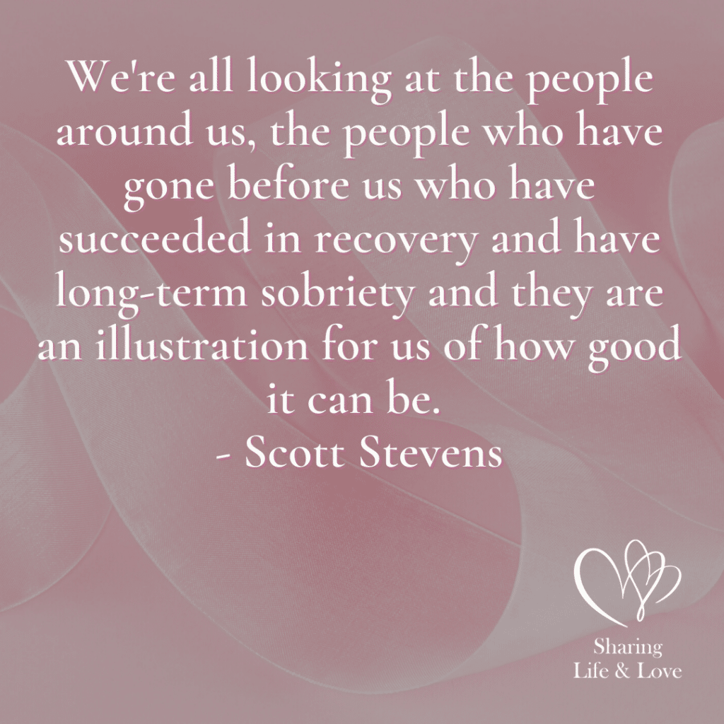

**“We’re all looking at the people around us,**

**The people who have gone before us who have succeeded in recovery and have long-term sobriety and they are illustration for us of how good it can be.”**

**Scott Stevens**

**Related**: [How to Deal with Gossip and Slander](https://sharinglifeandlove.com/blog/how-to-deal-with-gossip/)

### Column 2: The Cause

List **specific actions**that were taken against you in this column. If someone hurt you, list the specifics of what happened. Think about what made you feel fear or resentment. It’s important that you are as detailed as possible, as you will want to explain these things to your sponsor.

Being detailed by simply writing the words will **help you remember**what has happened in your past. According to CR, hurt people often hurt others, so you may have a lot of hurt and disappointment. Try not to let this get you too down, as it can be painful. Think about the good things to balance things out!

**Fear not,**

**For I am with you.**

**Do not be dismayed.**

**I am your God.**

**I will strengthen you;**

**I will help you;**

**I will uphold you with my victorious right hand.**

**Isaiah 41:10 (TLB)**

### Column 3: The Effect

List **how the specific hurtful actions affected your life**in the way that they did. Think about reality and recall the events that shaped your life.

To come up with the effects, **ask yourself**a few questions.

* What effect did these actions have on your past and present life?
* How did you overcome these past hurts, or how are you still overcoming them?
* What do you plan to do next in regards to these actions?

Remember, you have God on your side and can thus accomplish anything!

### Column 4: The Damage

List **the ways that you were injured**by the things that have happened in your past. As this step will be difficult, be sure to enlist the help of those you trust and spend plenty of time with God. Remember that you can overcome anything you set your mind to!

Some of the **basic instincts**that might have been injured or damaged include social, security, and sexual. **Socially**, you might have broken relationships or have [had to deal with slander and gossip](https://sharinglifeandlove.com/blog/how-to-deal-with-gossip/). If you have a broken or damaged marriage, you probably know pain very well.

Your **security**may have been threatened if you experienced physical harm or financial loss. **Sexually**, you might have had damage if you were in a sexually abusive relationship or have damaged intimacy in your life.

I love how the Celebrate Recovery literature explains how to get through this section. Remember that no matter how you’ve been hurt and no matter how much loss you have felt, **God is here for you**to comfort and restore you, so be sure to **lean on Him**during this time!

**I will look for those that are lost;**

**I will bring back those that wander off,**

**Bandage those that are hurt,**

**And heal those that are sick.**

**Ezekiel 34:16 (GNB)**

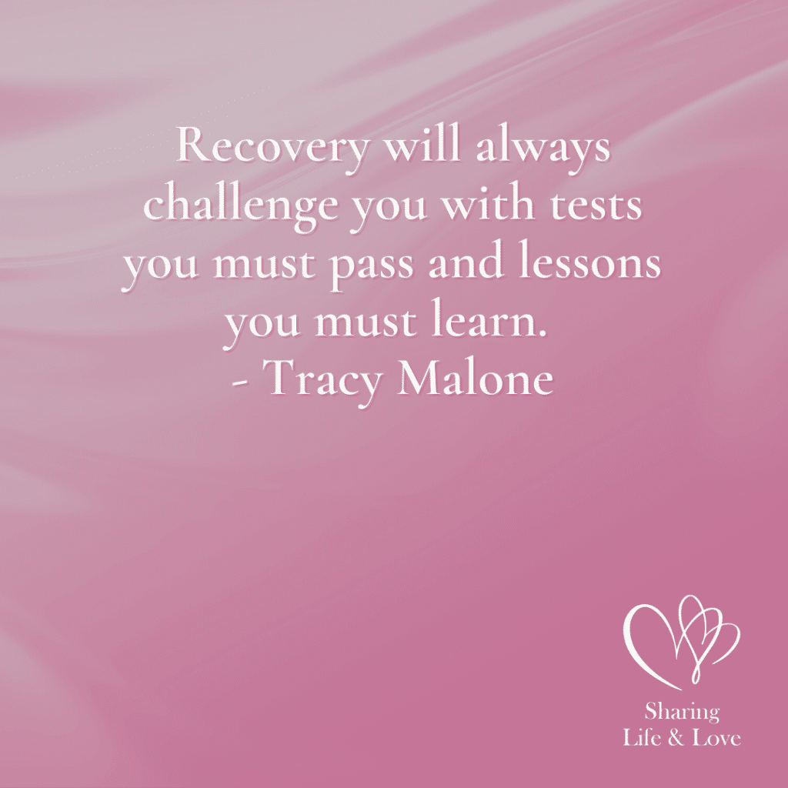

**“Recovery will always challenge you with tests you must past and lessons you must learn.”**

**Tracy Malone**

### Column 5: My Part

List **your responsibility**in everything. This won’t be easy because you might not realize where you are in the wrong. Pray to God to ask Him to show you what was or is your part in a damaged relationship. Ask for Him to reveal the part you played in a job loss or other loss in your life.

Additionally, you should **list everyone you have hurt and how you have hurt them**. Since you might not realize your part in all this, you will want to dig deep and pray plenty! Brainstorm the many things that have gone wrong in your life, and everything will soon all fall into place.

**Search me,**

**O God,**

**And know my heart;**

**Test me and know my anxious thoughts.**

**Point out anything in me that offends you and lead me along the path of everlasting life.**

**Psalm 139:23-24 (NLT)**

#### A Special Note for Abuse

If you were in an **abusive relationship**, especially as a child, this part of your inventory will be a bit different. Realize that you played NO part and had NO responsibility for the damage that happened to you!

For **relationships like this**, just write “None” in column 5 and begin liberating yourself from any shame or guilt that you have been carrying around. For more information on this, consult your CR literature or talk to your sponsor or group leader.

For those who have been in a **sexually or physically abusive relationship**, after speaking about this with your sponsor or group leader, realize that Celebrate Recovery has rewritten Step 4 for you. This is what you should memorize for step four instead:

We made a searching and fearless moral inventory of ourselves, realizing all wrongs can be forgiven. Renounce the lie that the abuse was our fault.

### More Celebrate Recovery Lesson 9 Tools

Along with these great points when creating your moral inventory, Celebrate Recovery has additional suggestions on how to get through this lesson. It is suggested that you **memorize scripture**, specifically Isaiah 1:18.

**“Come**

**Let’s talk this over!”**

**Says the Lord,**

**“No matter how deep the stain of your sins,**

**I can take it out and make you as clean as freshly fallen snow.**

**Even if you are stained as red as crimson,**

**I can make you white as wool!”**

**Isaiah 1:18 (TLB)**

Memorization techniques are further discussed in the article, [Celebrate Recovery Serenity Prayer](https://sharinglifeandlove.com/blog/celebrate-recovery-serenity-prayer/). This article also gives you a great prayer to memorize, which will help you in your recovery!

**Review additional Bible verses**(listed in the next section) that will help you in keeping your inventory balanced. It’s very important that you list both the good and the bad.

CR suggests that you **list the good things**that are revealed to you on the reverse side of your Moral Inventory Worksheet.

Additional suggestions include continuing to develop your **support team**, including your sponsor and accountability team members, and [praying continuously](https://sharinglifeandlove.com/blog/how-to-pray-for-beginners-a-complete-guide/). Remember, the more you pray, the closer you will be to God, and the easier things will be to get through!

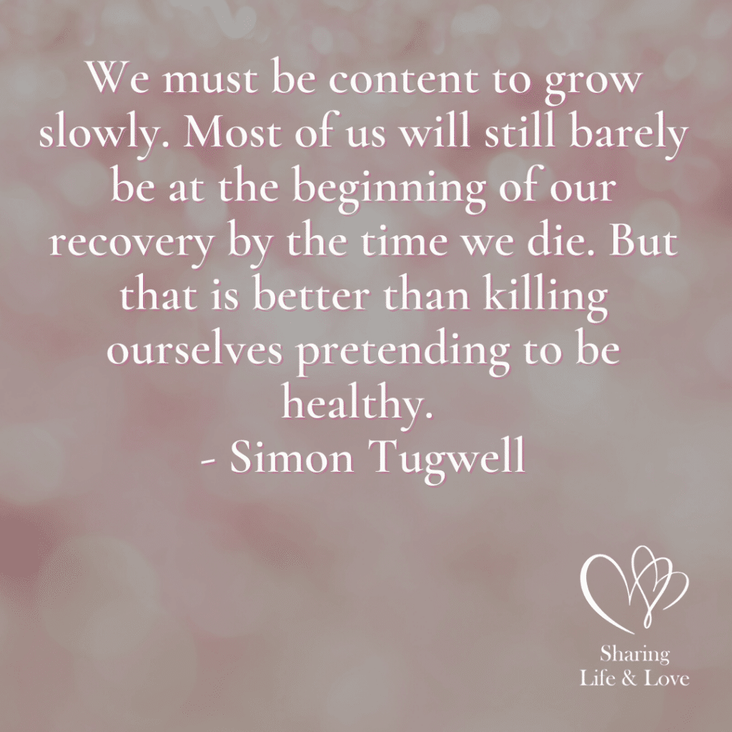

**“We must be content to grow slowly.**

**Most of us will still barley be at the beginning of our recovery by the time we die.**

**But that is better than killing ourselves pretending to be healthy.”**

**Simon Tugwell**

**Don’t worry about anything;**

**Instead,**

**Pray about everything.**

**Tell God what you need,**

**And thank Him for all He has done.**

**Philippians 4:6 (NLT)**

### Principle 4 Bible Verses

**For God is at work within you,**

**Helping you to want to obey him and then helping you do what he wants.**

**Philippians 2:13 (TLB)**

**When someone becomes a Christian,**

**He becomes a brand new person inside.**

**He is not the same anymore.**

**A new life has begun!**

**2 Corinthians 5:17 (TLB)**

**And it is He who will supply all your needs from his riches in glory because of what Christ Jesus has done for us.**

**Philippians 4:19 (TLB)**

**Jesus says,**

**“I am with you always.”**

**Matthew 28:20 (TLB)**

**All who are oppressed may come to Him.**

**He is a refuge for them in their times of trouble.**

**Psalm 9:9 (TLB)**

**Yes,**

**Be bold and strong!**

**Banish fear and doubt!**

**For remember,**

**The Lord your God is with you wherever you go.**

**Joshua 1:9 (TLB)**

**This is the day the Lord has made.**

**We will rejoice and be glad in it.**

**Psalm 118:24 (TLB)**

**Let him have all your worries and cares,**

**For he is always thinking about you and watching everything that concerns you.**

**1 Peter 5:7 (TLB)**

### Celebrate Recovery Lesson 9 Questions

These questions go directly with your **Moral Inventory Worksheet**.

* Who is the person or object you resent or fear?
* What action did that individual take that hurt you?
* What effect did that action have on your life?
* How did that action damage your basic instincts?
* What part of the effect are you responsible for?
* Who have you hurt?
* How did you hurt them?

## More Valuable Celebrate Recovery Lesson 9 Resources

### Free Recovery Lesson 9 Moral Inventory Worksheet

If you have the Celebrate Recovery study guide, you can make copies of the worksheet included. Alternatively, I’ve created a FREE [Recovery Lesson Nine Moral Inventory Worksheet](https://sharinglifeandlove.com/product/recovery-inventory-worksheet/)!

[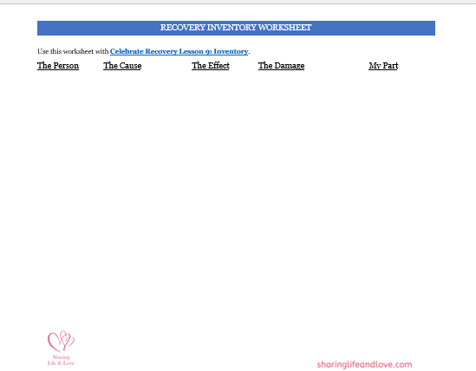](https://sharinglifeandlove.com/product/recovery-inventory-worksheet/)

## My Story – Celebrate Recovery Lesson 9

As mentioned in the previous lessons, I’m **Michele** and am a grateful believer in Jesus Christ. I celebrate recovery from addictions and alcoholism. I continue to struggle with perfectionism and social anxiety.

As my **moral inventory**is reserved for myself, God, and my sponsor, I won’t be sharing that here, but I will talk about the experience I had in working on it. It was rather complicated. There are things that have happened in my life that I don’t like to share.

I’ve noticed when you share **personal things**with other people, they often look at you differently. It’s like, wow, I didn’t know that about you! Now I [have juicy gossip](https://sharinglifeandlove.com/blog/how-to-deal-with-gossip/) to share!! Have you ever felt that way? I think when it comes to this process, you have to **trust God**.

Know that you are doing your best to choose someone to confide in, and the **Lord is watching over this experience**. He knows that you will be alright – no matter what this person thinks of you. I was fortunate to have a trustworthy sponsor, and I think you must pick someone like this.

At the same time, know that **God has your back**. He is watching over you, and you can **grow from this experience**. However, you will only **get**out of this experience what you choose to **give**to it. If you only halfway go through recovery, you will only halfway recover!

Try to remember to **build upon your relationship with God**as you go through this experience. If you learn nothing else from it, knowing who Christ Jesus is and what He has done for you will be the best knowledge worth having! He is our Lord and Savior!! Amen!

## Frequently Asked Questions

### What are the Celebrate Recovery 12 steps?

The **Celebrate Recovery (CR) 12 Steps**are also the 12 steps from Alcoholics Anonymous (AA).

1. We admitted we were powerless over our addictions and compulsive behaviors, that our lives had become unmanageable.
2. We came to believe that a power greater than ourselves could restore us to sanity.
3. We decided to turn our lives and our wills over to the care of God.
4. We made a searching and fearless moral inventory of ourselves.
5. We admitted to God, ourselves, and another human being the exact nature of our wrongs.
6. We were entirely ready to have God remove all these defects of character.
7. We humbly asked Him to remove all our shortcomings.
8. We made a list of all persons we had harmed and became willing to make amends to them all.
9. We made direct amends to such people wherever possible, except when to do so would injure them or others.
10. We continued to take personal inventory and, when we were wrong, promptly admitted it.
11. We sought through prayer and meditation to improve our conscious contact with God, praying only for knowledge of His will for us and the power to carry that out.
12. Having a spiritual experience resulting from these steps, we try to carry this message to others and practice these principles in all our affairs.

### What is the success rate in Celebrate Recovery?

As [some studies](https://showmetimes.com/Blogpost/uph8) have shown, the success rate of Celebrate Recovery (CR) as compared to Alcoholics Anonymous (AA) is about 85%! That is pretty high for a 12-step recovery program! The main difference between the two programs is Jesus Christ! CR and AA both follow the same 12 steps, though.

### What are Celebrate Recovery 8 principles?

The [**8 principles of Celebrate Recovery**](https://sharinglifeandlove.com/blog/celebrate-recovery-8-principles-of-recovery-what-they-mean/)are the following:

1. Realize I’m not God. I admit that I am powerless to control my tendency to do the wrong thing and that my life is unmanageable.
2. Earnestly believe that God exists, that I matter to Him, and that He has the power to help me recover.
3. Consciously choose to commit all my life and will to Christ’s care and control.
4. Openly examine and confess my faults to me, to God, and to someone I trust.
5. Voluntarily submit to every change God wants to make in my life and humbly ask Him to remove my character defects.
6. Evaluate all my relationships. Offer forgiveness to those who have hurt me and make amends for harm I’ve done to others, except when to do so would harm them or others.
7. Reserve a daily time with God for self-examination, Bible reading, and prayer to know God and His will for my life and to gain the power to follow His will.
8. Yield myself to God to be used to bring this Good News to others, both by my example and by my words.

### How do you Celebrate Recovery?

You can “celebrate” recovery if you are in a 12-step recovery program or have graduated from a program like this, but “[Celebrate Recovery](https://sharinglifeandlove.com/blog/what-is-celebrate-recovery/)” is itself a 12-step recovery program. CR, as it’s also known, is a Christ-centered recovery program with many similarities to AA (Alcoholics Anonymous).

### What is the Celebrate Recovery Serenity Prayer?

The [Celebrate Recovery Serenity Prayer](https://sharinglifeandlove.com/blog/celebrate-recovery-serenity-prayer/) is as follows: God, grant me the serenity to accept the things I cannot change, the courage to change the things I can, and the wisdom to know the difference. I would recommend keeping a copy with you or memorizing it!

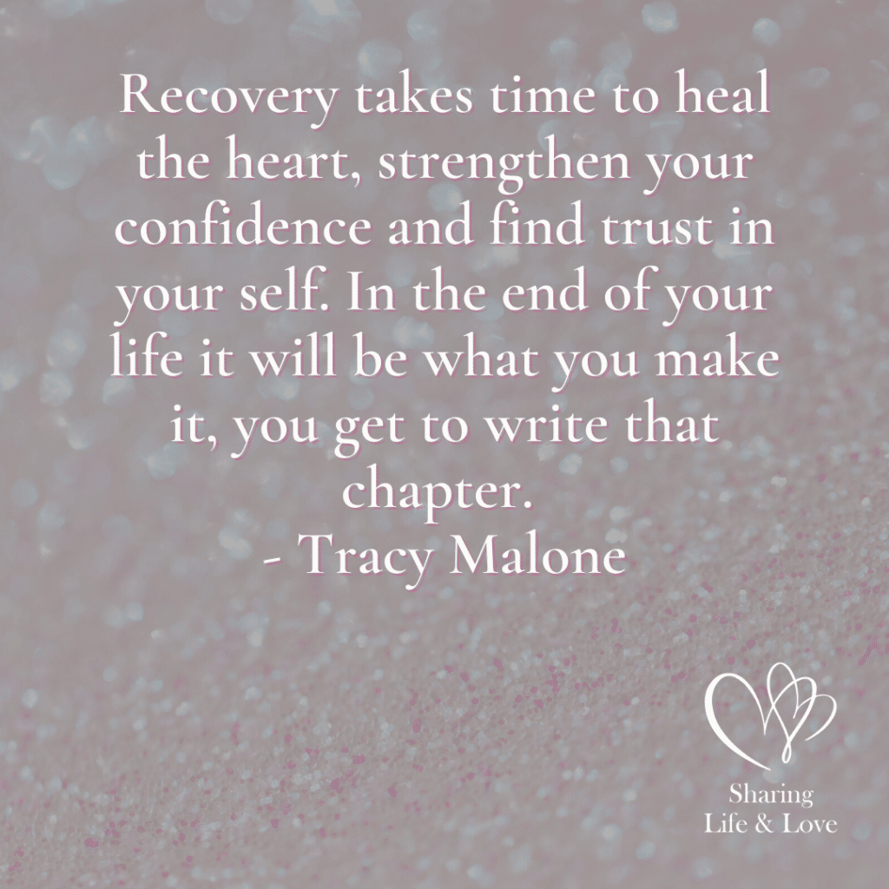

**“Recovery takes time to heal the heart,**

**Strengthen your confidence and find trust in yourself.**

**In the end it will be what you make it,**

**You get to write that chapter.”**

**Tracy Malone**

## Conclusion

On **your road to recovery,**you pray that you will see much success! We have discussed the following in this article:

* What is Celebrate Recovery Lesson 9: Moral?
* What is Celebrate Recovery?
* Notes from Celebrate Recovery Lesson 9
* Questions from the Celebrate Recovery Lesson 9 Study Guide
* [A FREE Recovery Lesson 9 Inventory Worksheet](https://sharinglifeandlove.com/product/recovery-inventory-worksheet/)
* My Takeaways from Celebrate Recovery Lesson 9
* & Much More!